

CPIT-380 PROJECT REPORT

**Instructed by Dr. Saim Rasheed**



February 2023

|  |  |  |
| --- | --- | --- |
| Name | Student ID | Section |
| Abdulaziz Al-Sharif | 2036023 | IT1 |
| Rakan Salama | 2037276 |
| Omar Al-Zahrani | 2040569 |
| Fahad Al-Sifri | 1943998 |
| Majed Al-Ghamdi | 1942874 |



Table of Contents

Main menu 5

1. Files Menu 6

Browse Code 7

Reset Code 7

Save Code 7

1. Color change 8

Change red,green,blue colors using sliders code 9

Clear red code 10

Clear green code 10

Clear blue code 10

Darker Code 10

Brighter Code 11

1. Copy and Crop 11

Crop Code 12

1. Convert RGB to Gray Scale Image 13

Convert RGB to Gray Scale Image code 13

4- ................................................................................................................................................................. 14

Convert Gray scale to Binary Image using thresholding technique code 15

1. Convert and RGB image to HSV colored image 15

Convert and RGB image to HSV colored image code 16

1. Blending Two or more images 17

Blending Two or more images code 18

7 + 8- Left/right/180 rotations: 19

Left Rotation code 19

Right Rotation code 20

180 degree Rotation code 20

9 + 10 + 11- Reflections (Vertical, horizontal, Diagonal) 21

Horizontal Code 23



Vertical code 23

Diagonal D1 Code 24

Diagonal D2 Code 24

12 + 13- Scalling Up/Down: 25

Scaling Up/Down Code 25

1. Create Collage 26

Create Collage Code 27

1. Computing histograms 28

Computing histograms for red 29

Computing histograms for Green 29

Computing histograms for Blue 30

Computing histograms for gray scale 30

1. Reconstruction of Image using Histogram(BONUS): 31

Export Histogram Code 31

Import Histogram Code 32

1. Computing Contrast 33

Computing contrast code 34

Adjustment of contrast using a slider code 35

19 + 20 + 21 + 22 + 23- Filters(Box,Gaussian,Laplacian,Min,Max,Median and Weighted median) 36

Box Filter code 37

Min Filter Code 38

Max Filter Code 39

Gaussian Filter Code 40

Laplacian Filter Code 41

Weighted median Filter Code 43

1. Red Eye Reduction using thresholding technique 43

Red Eye Reduction using thresholding technique Code 44

1. Automatic detection of red eyes 45

Automatic detection of red eyes Code 46



1. Background Subtraction 46

Background Subtraction Code 47

1. Edge Detection methods 48

Edge Detection methods Code 49

1. Change Volume Using Slider 50

Change Volume using a slider code 50

29 - Clipping a given sound 51

Clip code 51

1. Splicing at least two sounds together keeping the silent zone 52

Splice code 53

1. Spread & squeeze a sound 54

Spread & squeeze code 55

1. Reversing and Mirroring 55

Reversing code 56

Mirror code 56

1. Blending Two or more sounds 57

Blend code 58

1. Apply simple average, weighted average, max, min and median filters on sounds 59

SoundFilters code 60

1. Create Rectangle Movie method, Show it is moving from top right corner to bottom left, curved trajectory 61

Top right to bottom left code 62

Top Left to bottom Right code 63

1. Create Rectangle Movie method, Show the trajectory of motion followed by a Sine function 63

Sine wave code 64

1. Create Rectangle Movie method Show the trajectory of motion, when a ball is dropped on the floor

.................................................................................................................................................................... 64

Dropp ball code 65

1. CreateTickerTapeMovie – A string of text moves back and forth and does not disappear from screen

.................................................................................................................................................................... 66



TickerTapeMovie code 67

1. Create a movie, cropping a part of given image that appears randomly on screen 68

Cropping and move in a video code 69

1. Create Sunset movie 69

Create Sunset movie Code 70

1. Back Ground Subtraction Movie 71

Back Ground Subtraction Movie Code 72

1. Edge Detection Movie 72

Edge Detection Movie Code: 73

1. Compare two Images 74

Compare two Images code 74

1. Shot boundary detection 75

Shot boundary detection code 76

1. Detecting a violation of traffic rule 77

Detecting a violation of traffic rule code 77

1. Object Detection 78

Object detection code 78

**Note: We have a github format that has all the details like videos and sounds, please check it out.**

**https://github.com/Nero-69/Cpit380Project**



# Main menu:

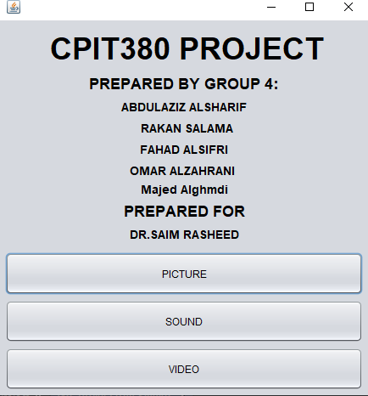

In the main menu, users can choose which section they want to edit by pressing the corresponding button.

Please Watch this video to learn how to upload our project and don’t forget to fill the google form ♥  
Youtube videos : <https://www.youtube.com/watch?v=fjpwWmMdilE&ab_channel=Nero>

Google form: https://docs.google.com/forms/d/e/1FAIpQLSd_4BxOBD0WKhbCigF-rGkjjsyPQ1UEMUC1fCGNlhJKJ8YOaQ/viewform?fbzx=8509294189677587184



# Files Menu:

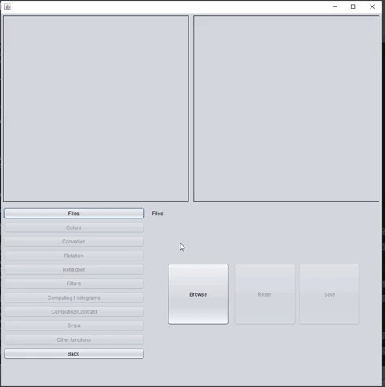

User can browse for image to activate the buttons, and they can reset the image to the original photo, at the end they can save the edited image.



Browse Code:

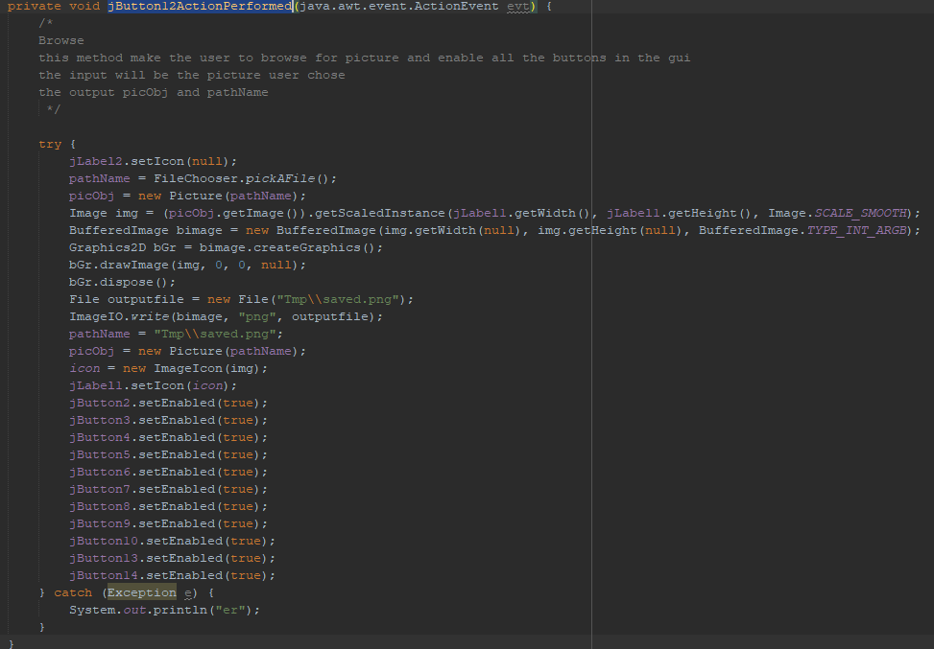

Reset Code:

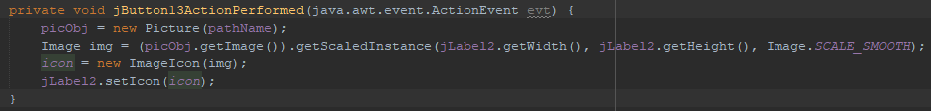

Save Code:

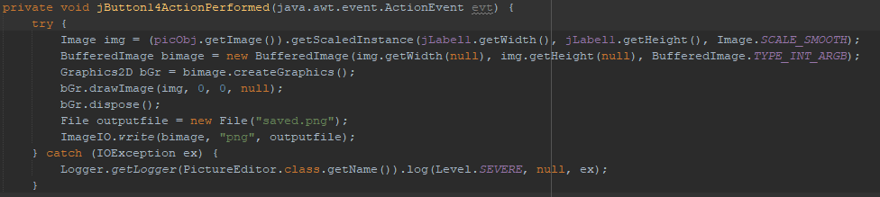



# ChangeColorsColor change:

* + Users can customize the RGB colors of their choice by clicking on the color box, adjusting the slider to the desired amount, and selecting whether to increase or decrease the color value. Once they've adjusted the colors to their liking, they can click the "Apply" button to apply the changes.
  + Users can remove red from the picture by clicking on the 'Clear red' button.
  + Users can remove green from the picture by clicking on the 'Clear green' button.



* + Users can remove blue from the picture by clicking on the 'Clear blue' button.
  + Users can adjust the darkness of the image by clicking the "Darken" button.
  + Users can adjust the brightness of the picture by clicking on the "Brighter" button.

Change red,green,blue colors using sliders code:

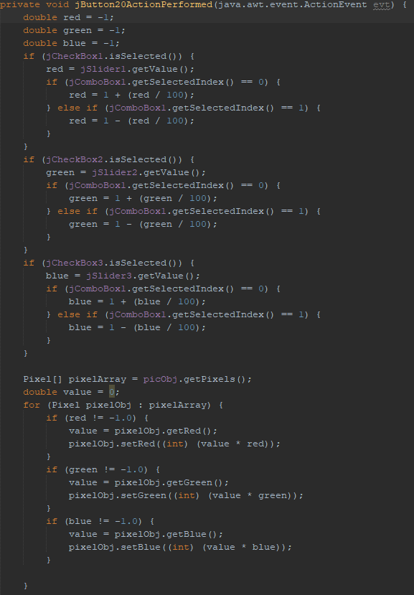



Clear red code:

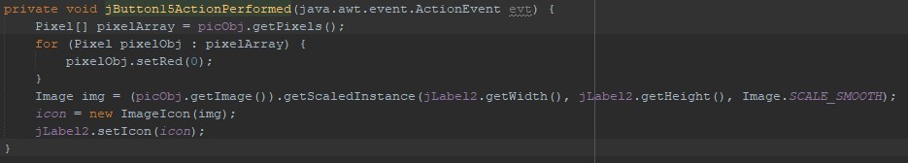

Clear green code:

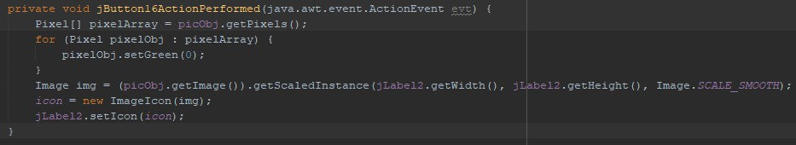

Clear blue code:

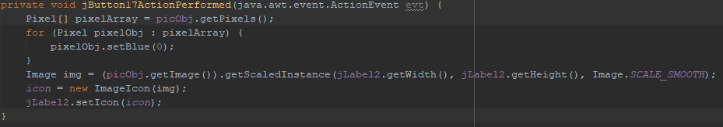

Darker Code:

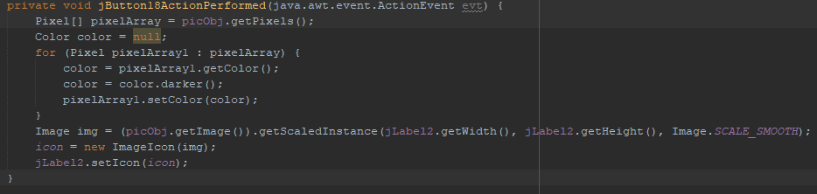



Brighter Code:

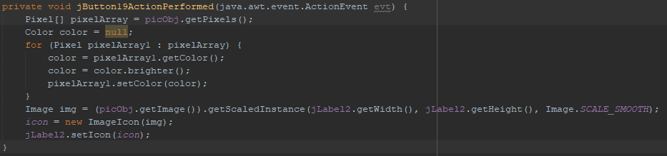

# giphyCopy and Crop



Users can crop any part of the picture by selecting the starting point and the ending point with two clicks. The first click will mark the beginning of the cropping area and the second click will mark the end of the cropping area.

Crop Code:

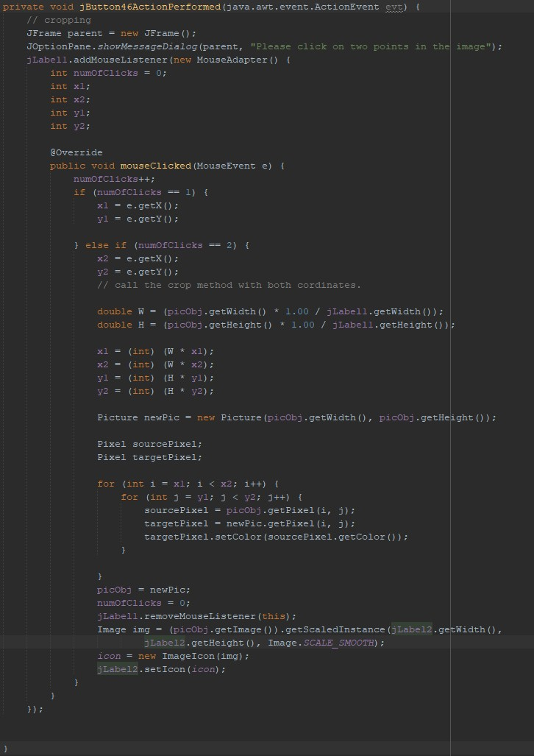



# Convert RGB to Gray Scale Image:

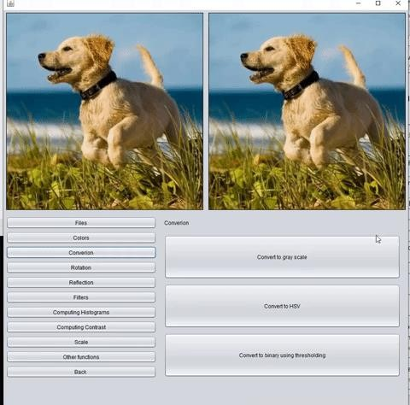

By pressing the "Convert to Gray Scale" button, users can change the colors of the picture to gray.

Convert RGB to Gray Scale Image code:

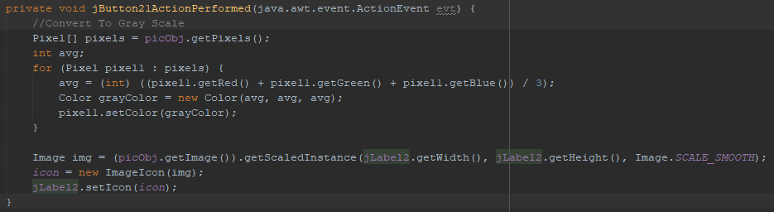



# Convert Gray scale to Binary Image using thresholding technique

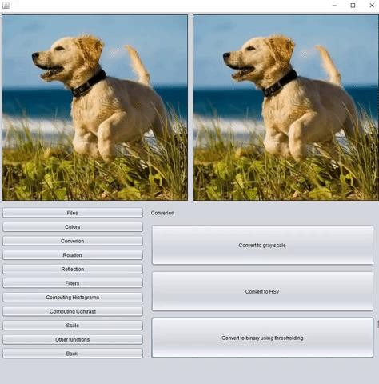

Users will select a threshold value, which will be used to convert an image to grayscale and then to a binary Image.



Convert Gray scale to Binary Image using thresholding technique code:

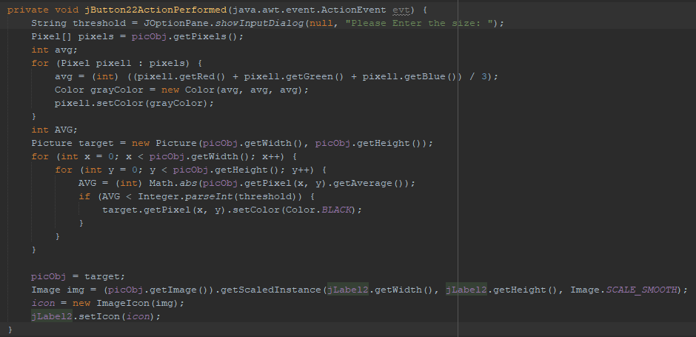

# Convert and RGB image to HSV colored image:

When users press the button "convert to HSV" the values of the pixels will be converted from RGB into HSV . The output will be the same.



Convert and RGB image to HSV colored image code:

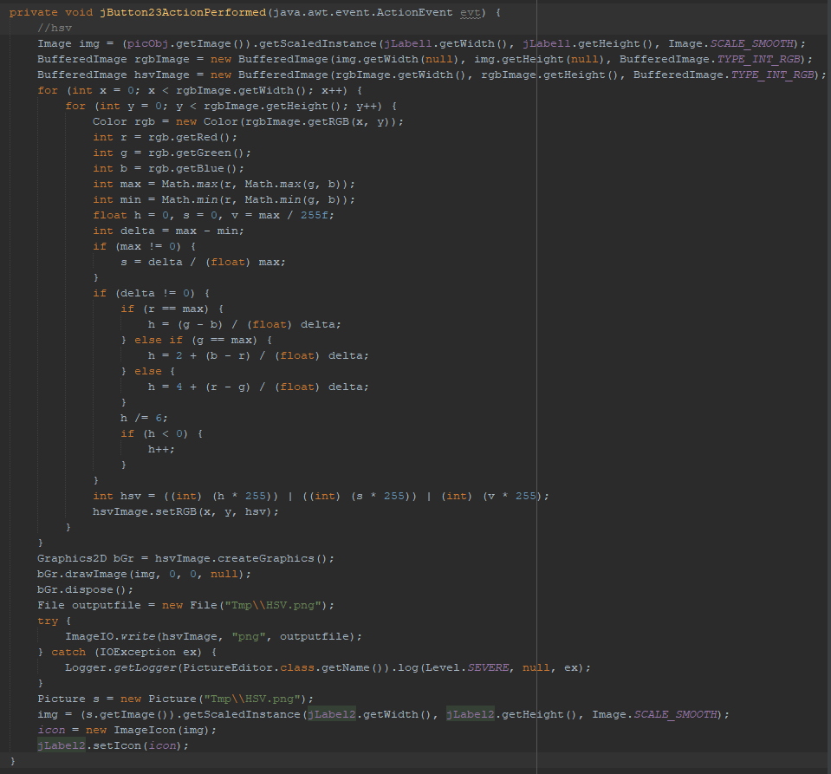



# Blending Two or more images:

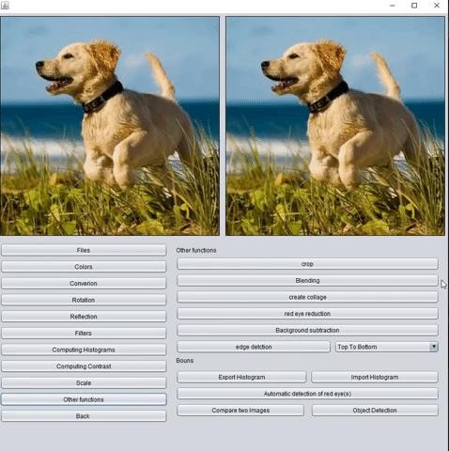

Users can blend 2 or more picture into one picture by pressing the button "Blending".



Blending Two or more images code:

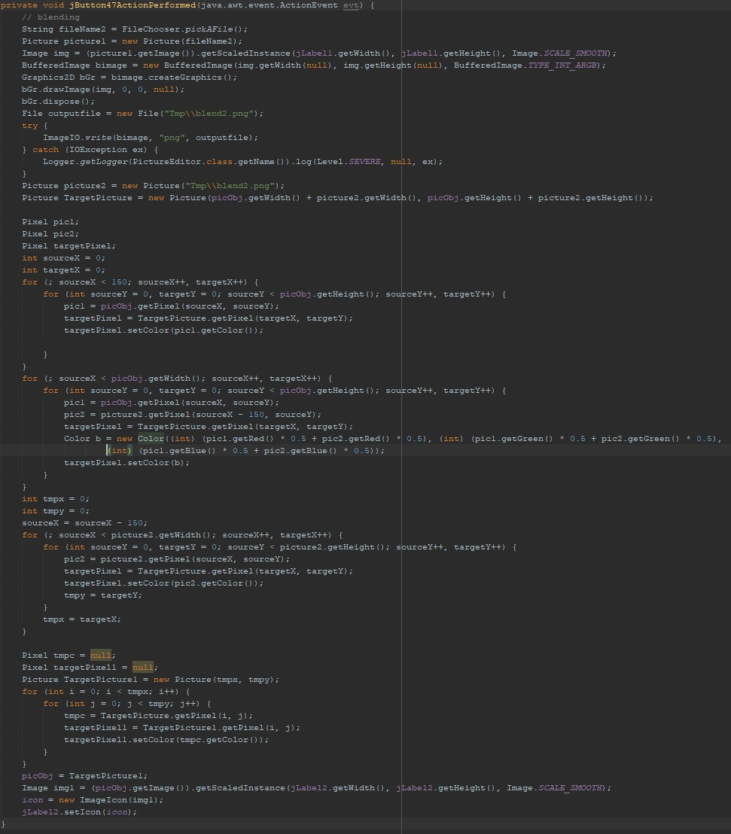



# giphy (4)7 + 8- Left/right/180 rotations:

Pressing "Left Rotations" allows users to rotate the selected picture to the left, while "Right Rotations" rotates it to the right. For a 180-degree rotation, press the button "Rotation by 180".

Left Rotation code:

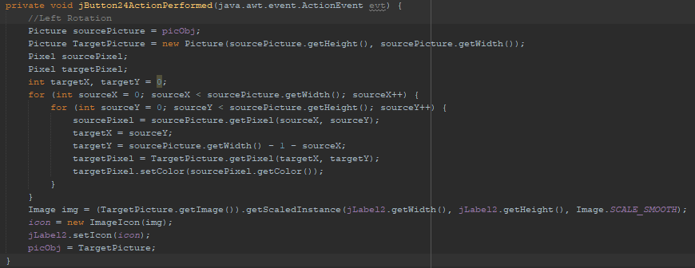



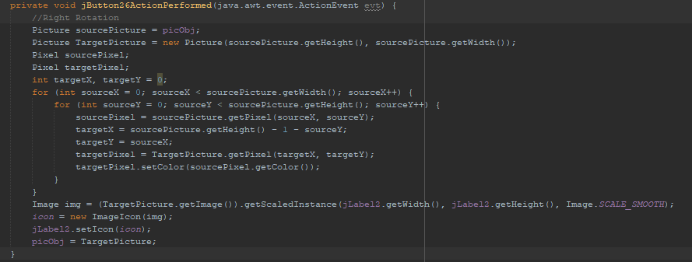Right Rotation code:

180 degree Rotation code:

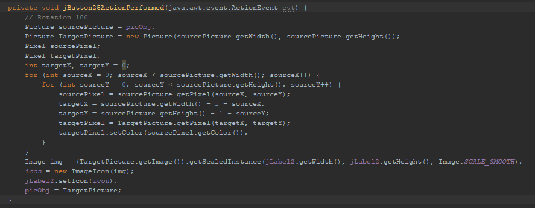



# 9 + 10 + 11- Reflections (Vertical, horizontal, Diagonal):

Vertical LR:

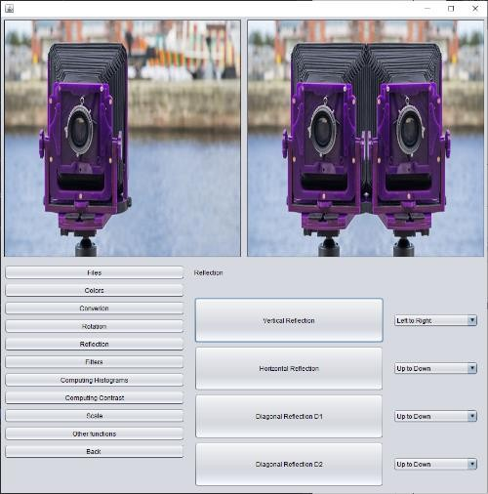

Horizontal UD:

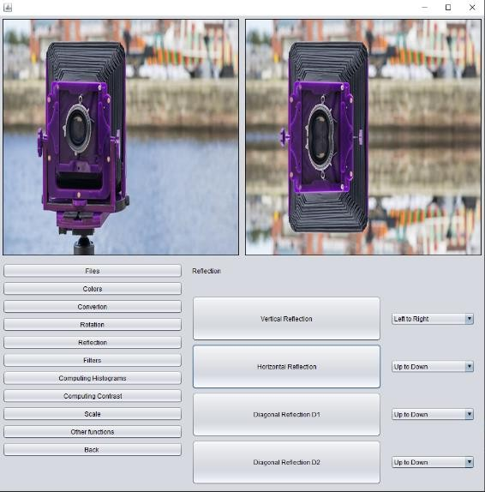



Diagonal D1 UD:

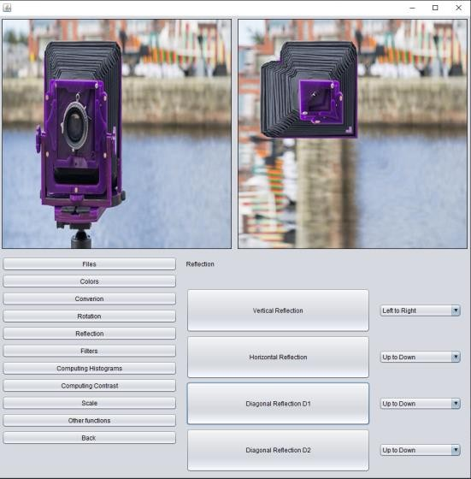

Diagonal D2 UD:

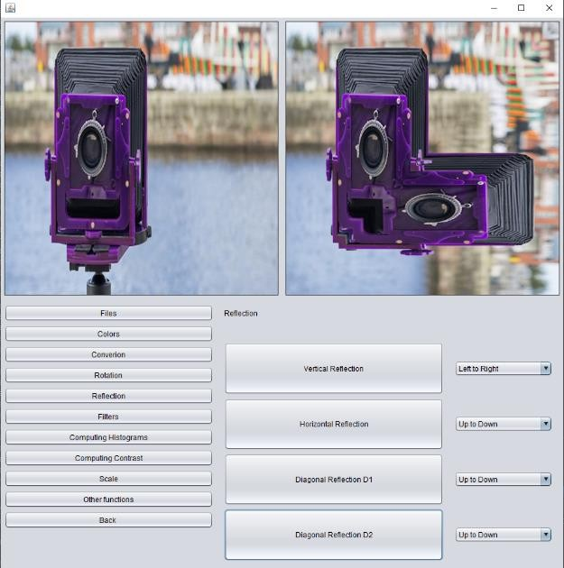



Horizontal Code:

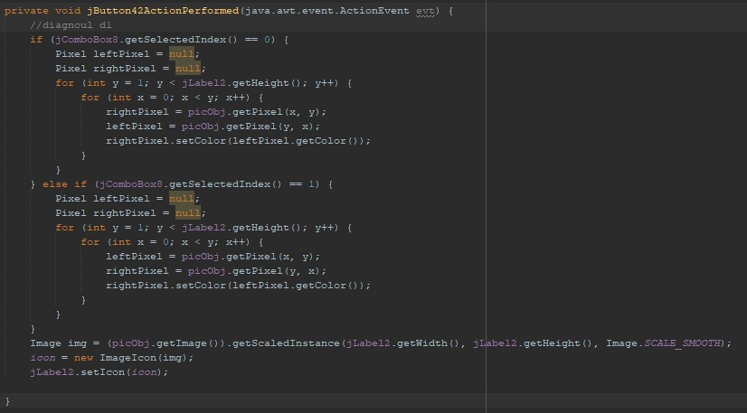

Vertical code:

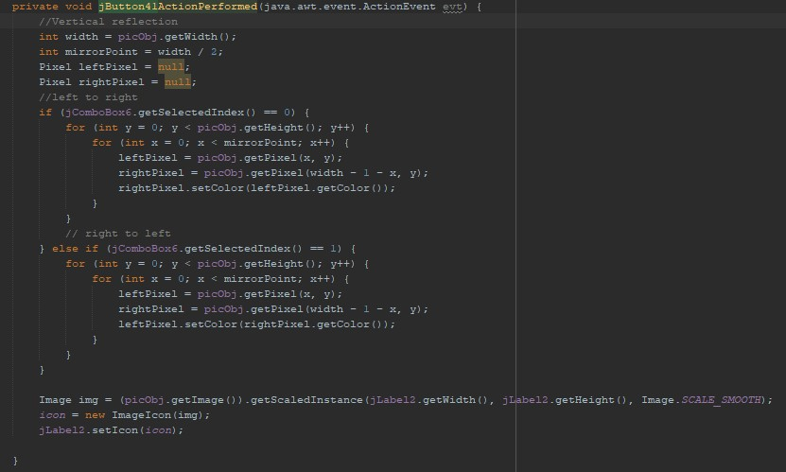



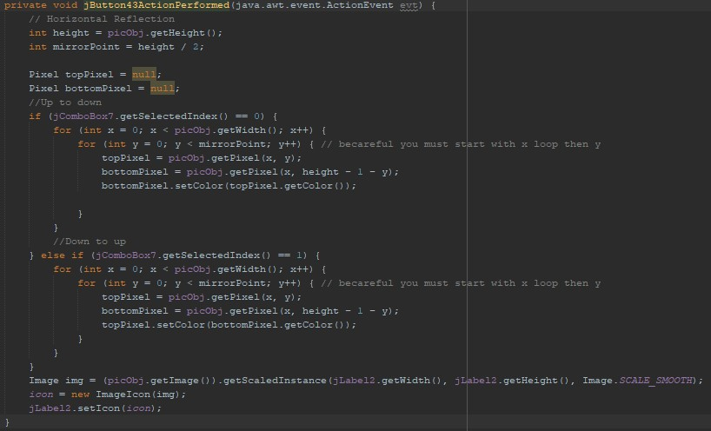Diagonal D1 Code:

Diagonal D2 Code:

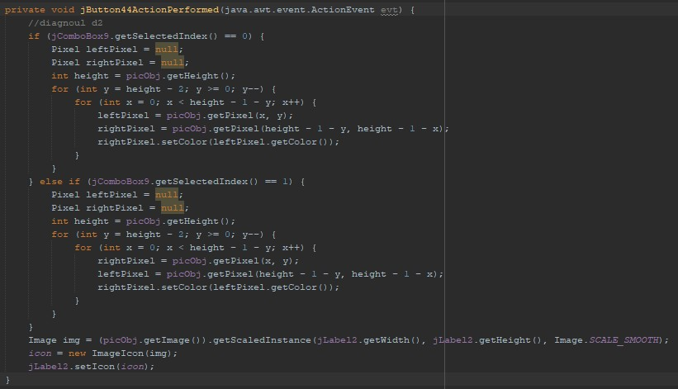



# giphy (5)12 + 13- Scalling Up/Down:

Users can adjust the size of the picture by using the slider. Moving it to the left will cause the picture to scale down, and moving it to the right will cause it to scale up. To apply the changes, press the "apply" button.

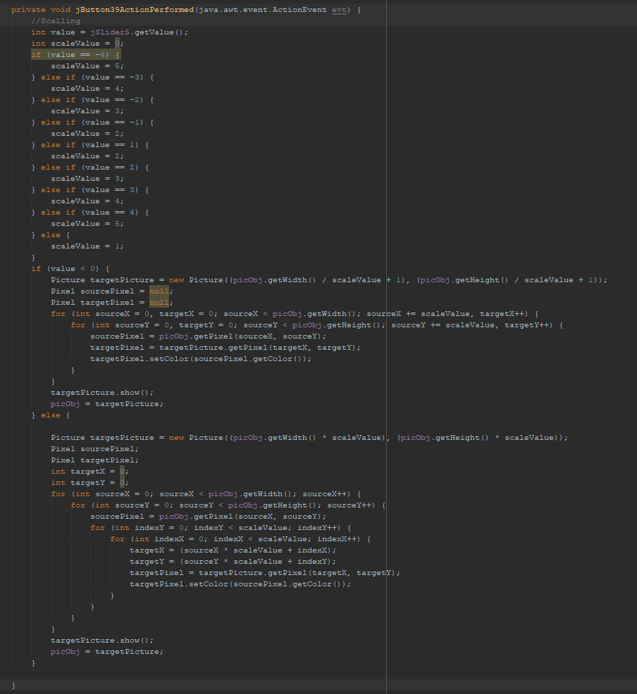Scaling Up/Down Code:



# Create Collage:

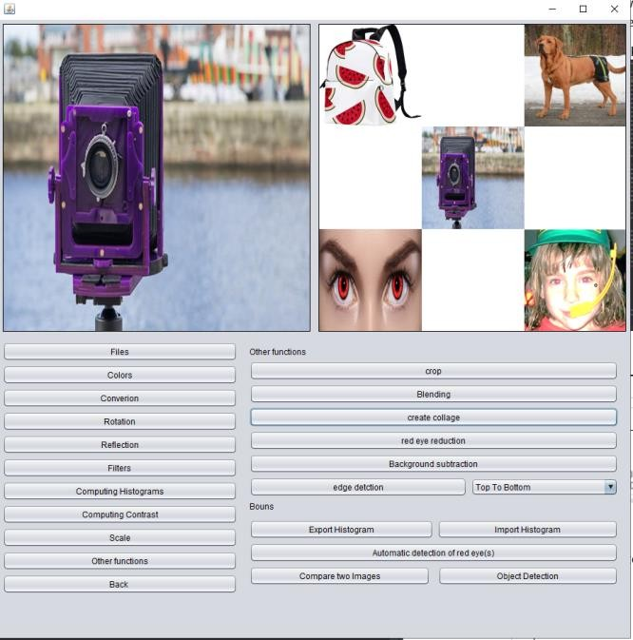

Users can create a collage by placing four different pictures into the corners, with the previously selected image in the center.



Create Collage Code:

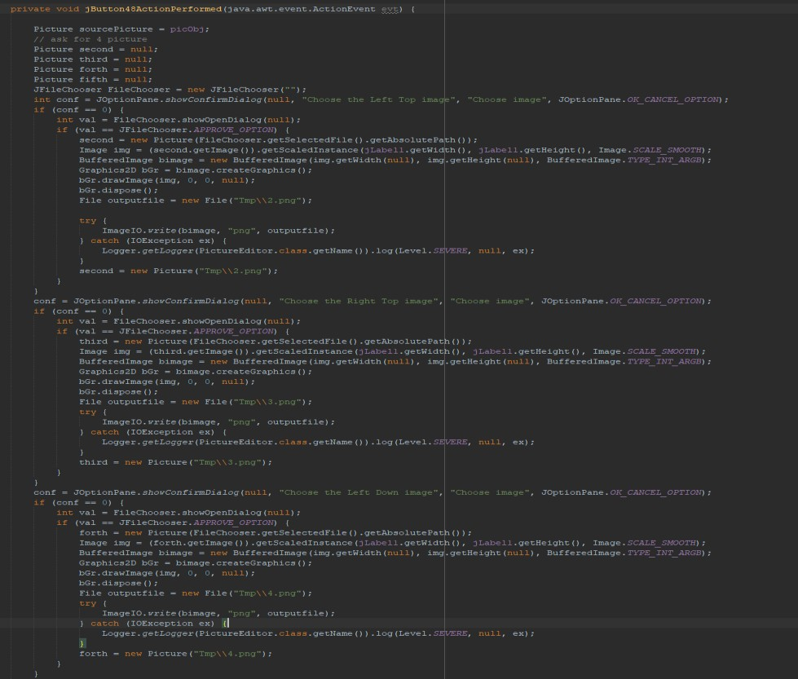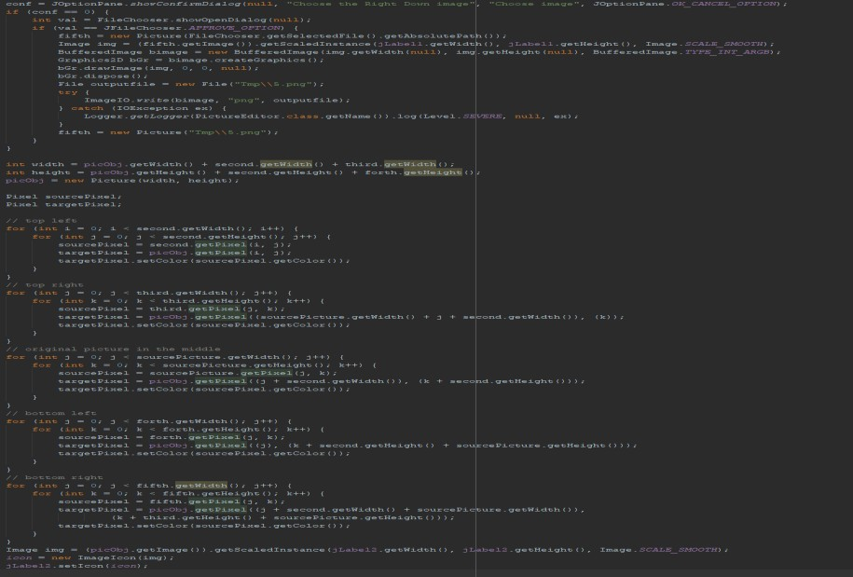



# Computing histograms:

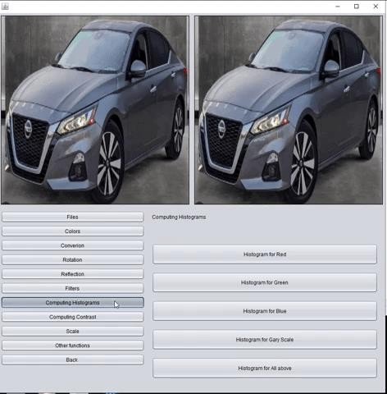

Computing histograms For all RGB color and the Gray scale, every color in separate button GUI, and it will represent it in GUI graph of the choosing histogram color.



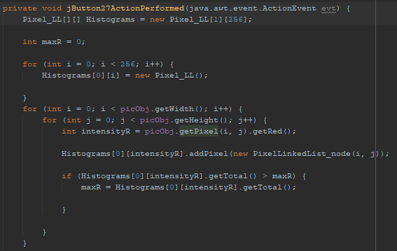Computing histograms for red :

Computing histograms for Green :

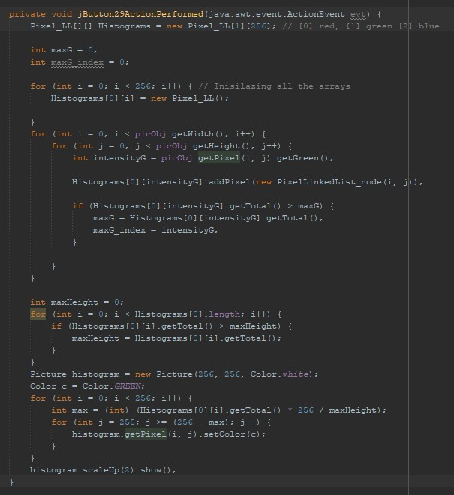



Computing histograms for Blue :

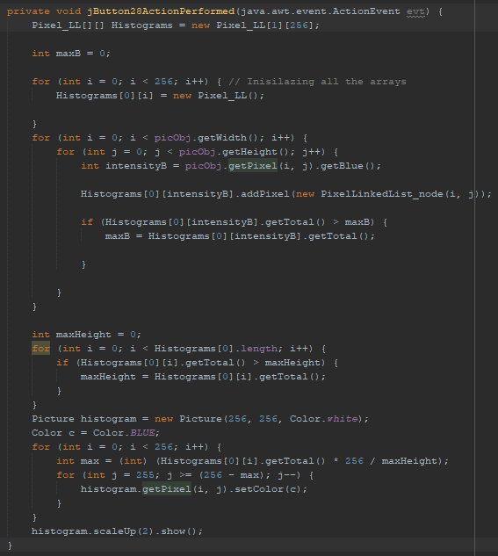

Computing histograms for gray scale:

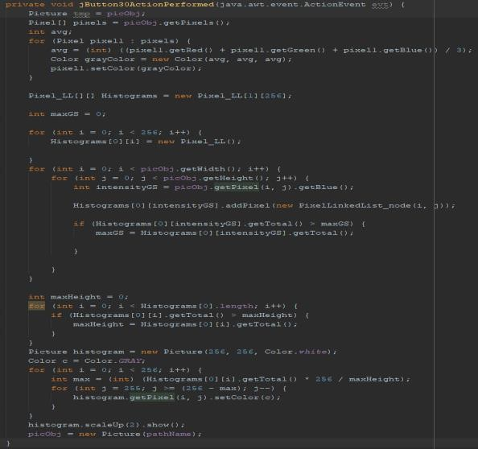



# 16Reconstruction of Image using Histogram(BONUS):

Export Histogram TXT that contain saved location information of a pixel and the intensity of the pixel using linked list, first the user browse for photo they want to save it than when they need it press import to reconstruct the photo.

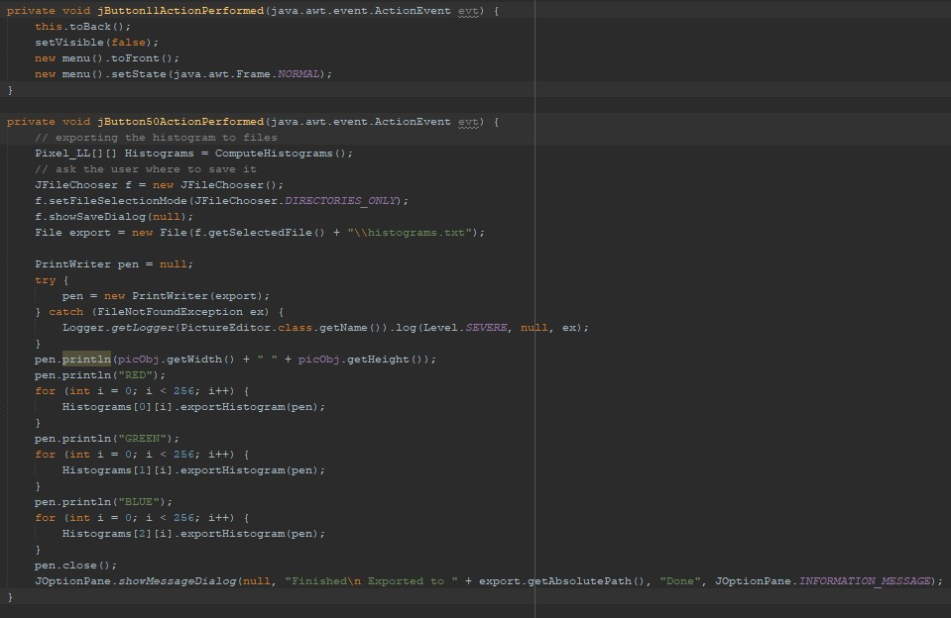Export Histogram Code:



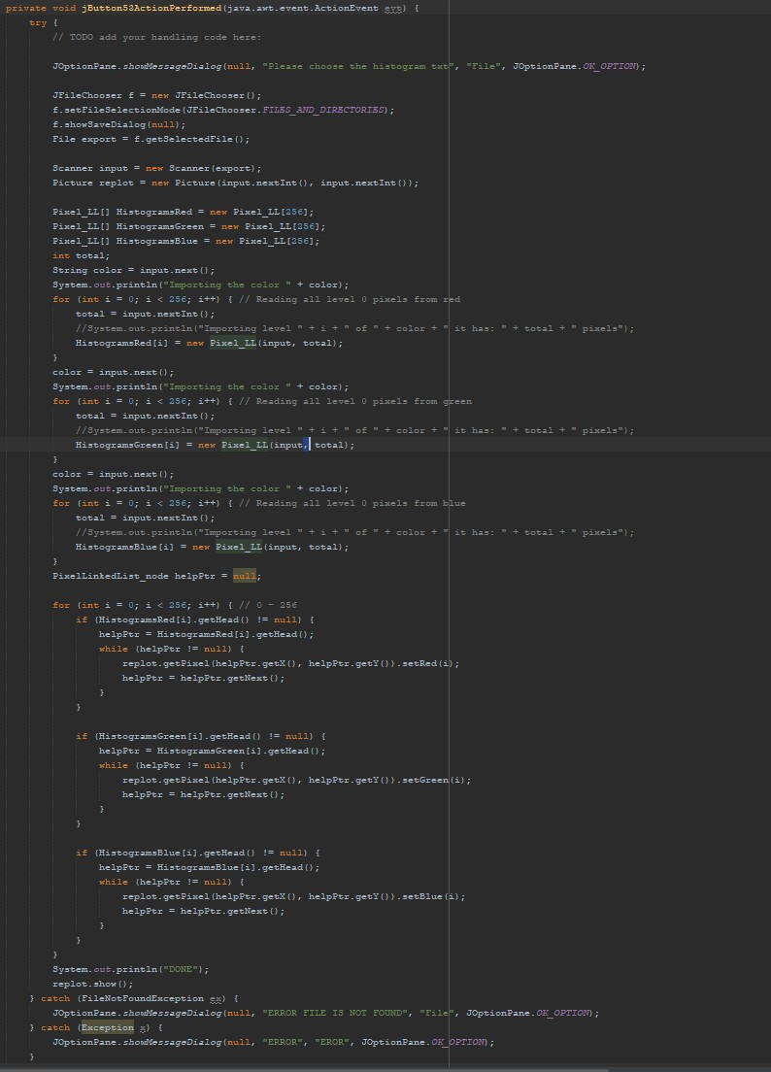Import Histogram Code:



# Computing Contrast:

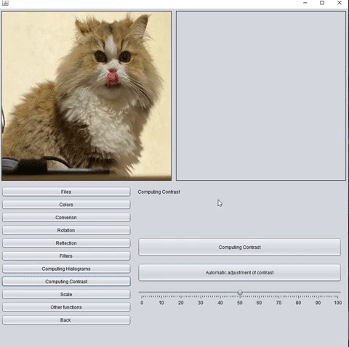

By pressing the "Computing contrast" button, users can see what the contrast level of an inserted picture is, ranging from 0 to 1.

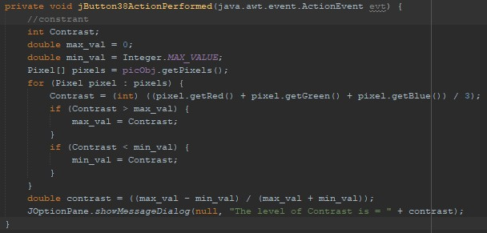Computing contrast code:

# Automatic adjustment of contrast using slider:

18-



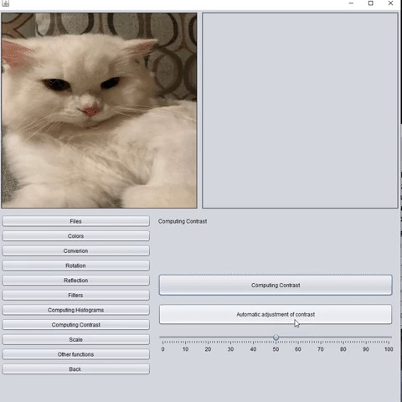



Users can adjust the contrast of the chosen picture by using a slider. Moving the slider to the right increases the contrast, while moving it to the left decreases it. To ensure the changes take effect, users must press the "Automatic adjustment of contrast" button.

Adjustment of contrast using a slider code:

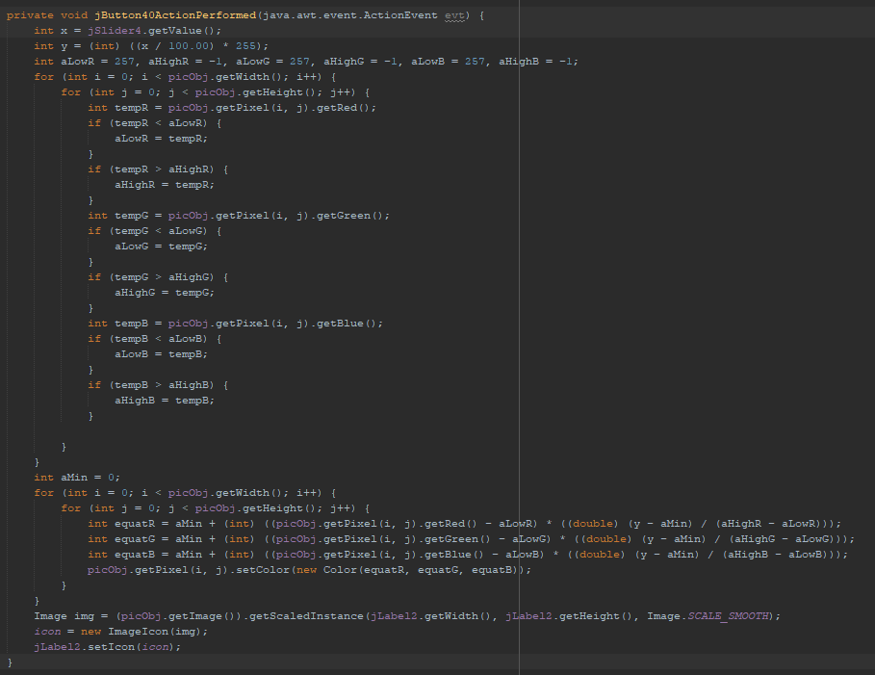



# 19 + 20 + 21 + 22 + 23-

Filters(Box,Gaussian,Laplacian,Min,Max,Median and Weighted median)

To apply Box, min and max filters, users must enter an odd number, such as 3, 5, 7 or 9, and then check the corresponding box and press the button for the filter they want. For Gaussian, median and weighted median filters, simply press the button to apply the changes. For Laplacian filter, users must select which Laplacian change to implement and then press the “Laplacian filter” button to apply the changes.

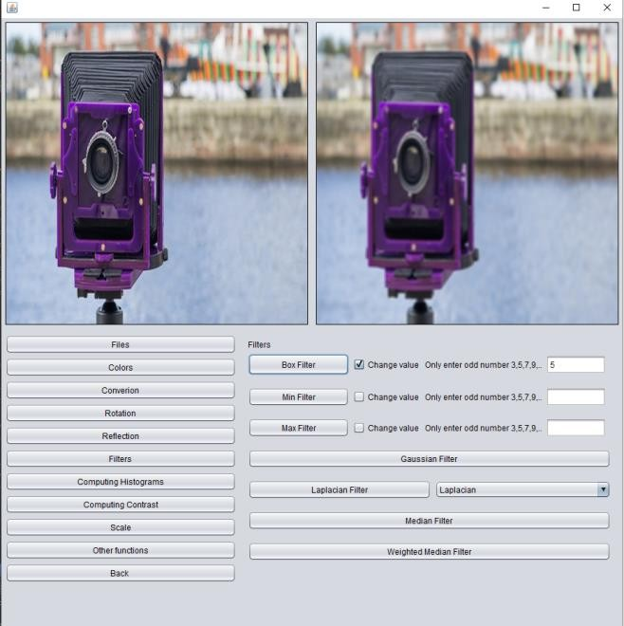Box Filter:



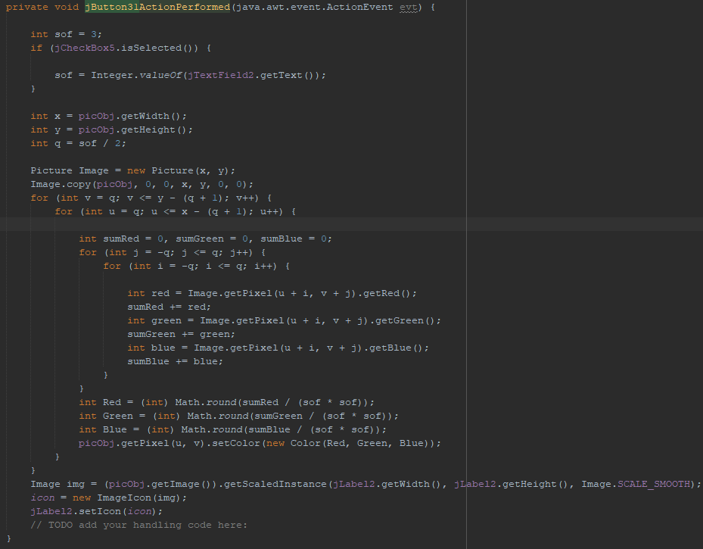Box Filter code:

Min Filter:

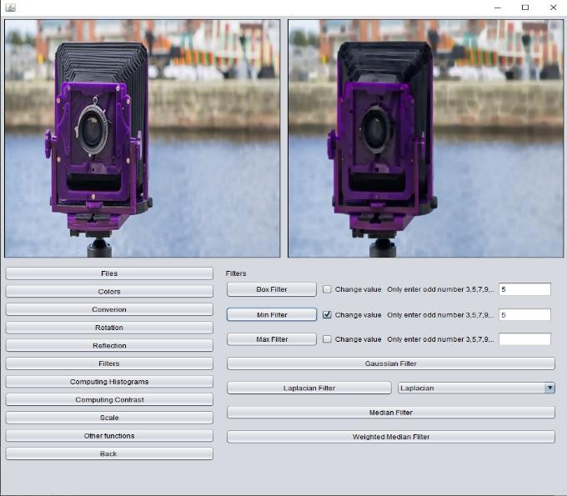



Min Filter Code:

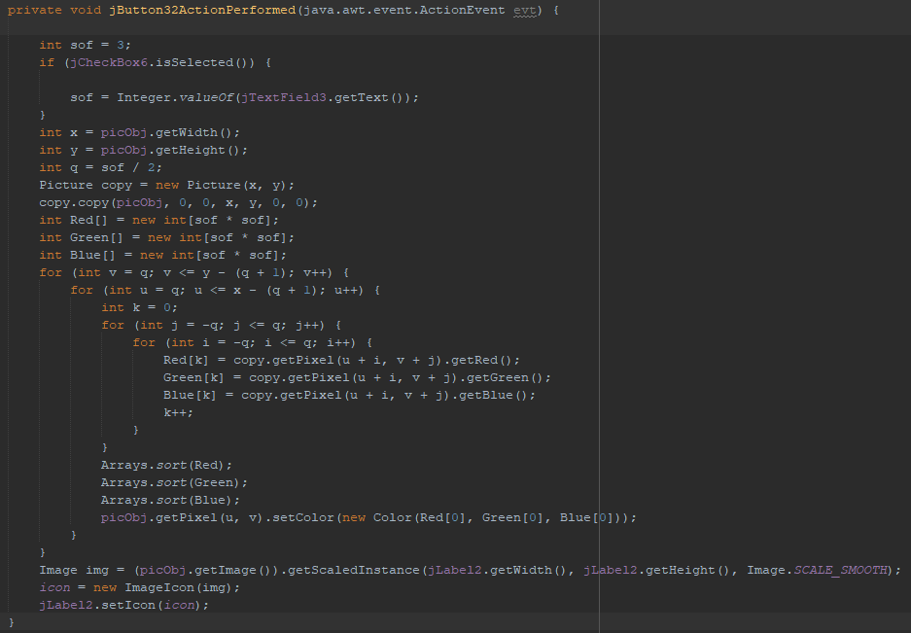

Max Filter:

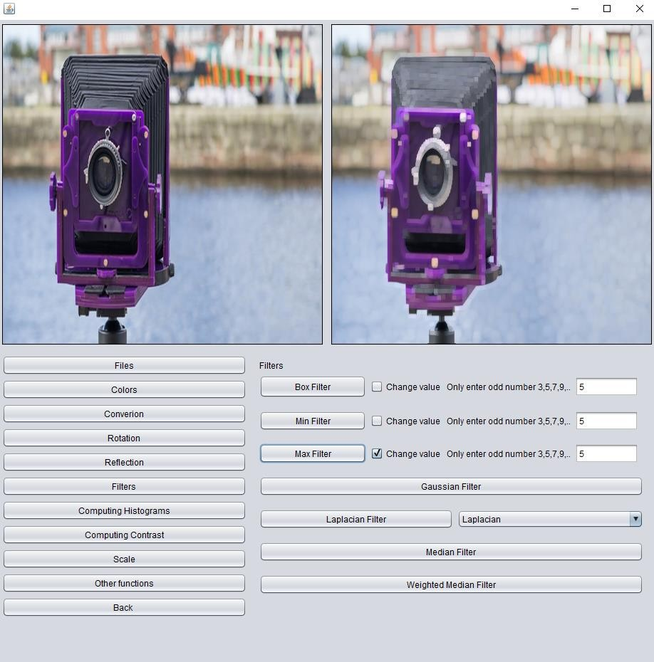



Max Filter Code:

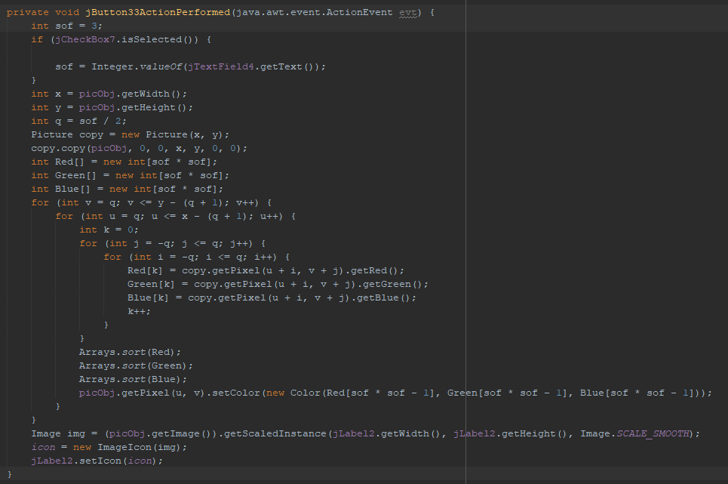

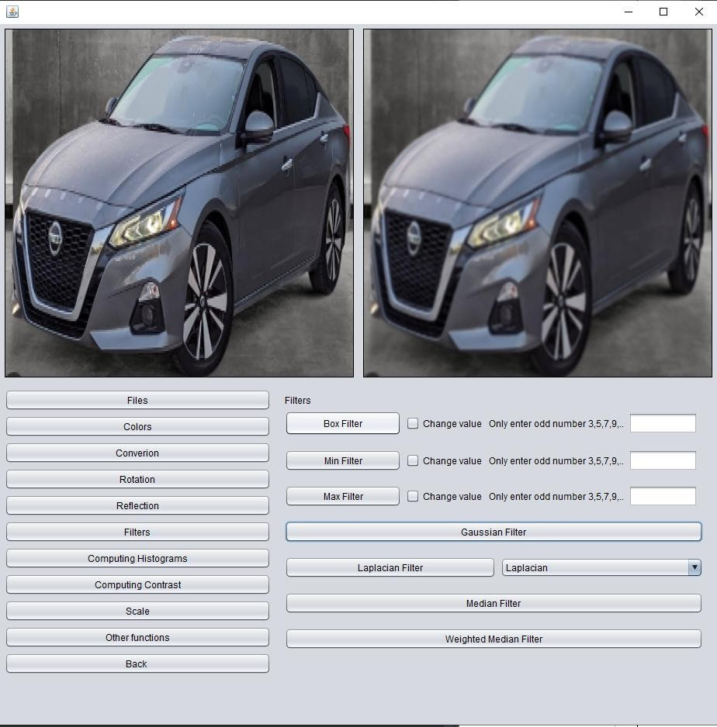Gaussian Filter:



Gaussian Filter Code:

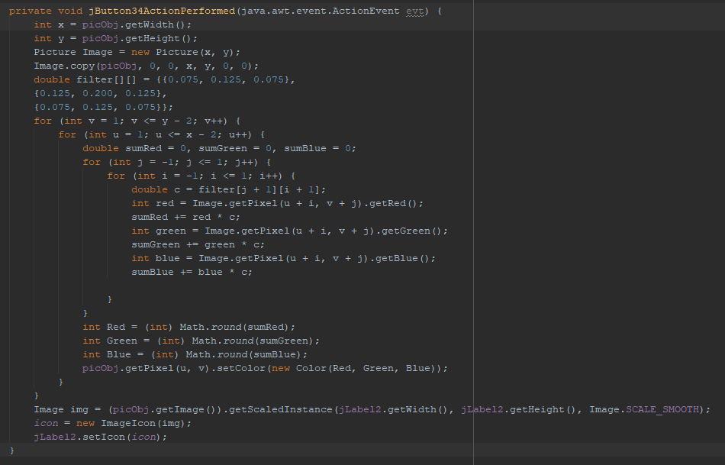

Laplacian Filter:

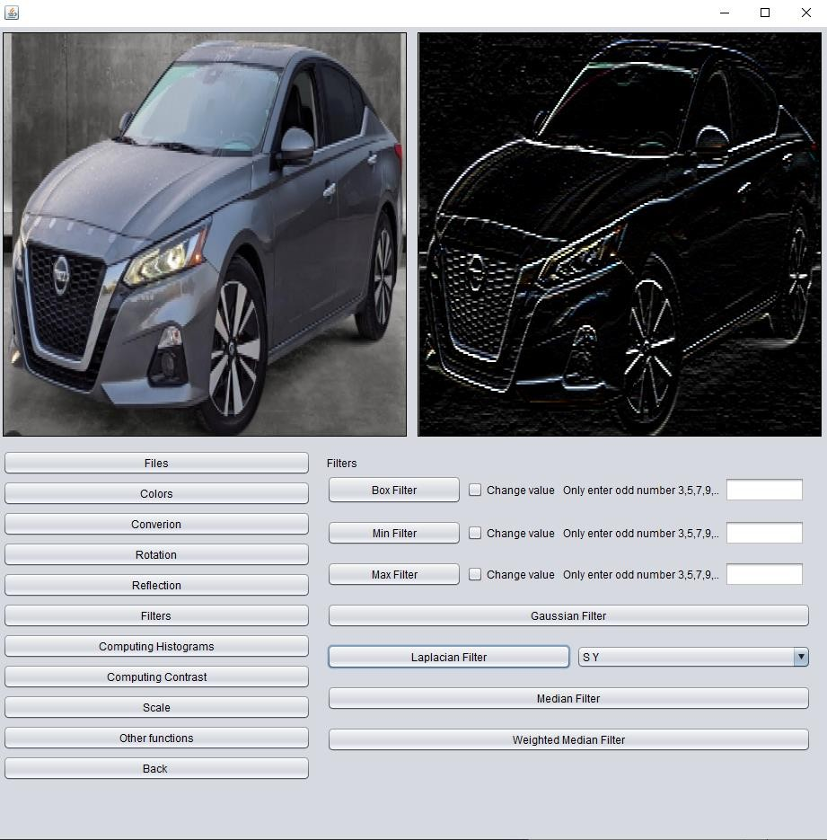



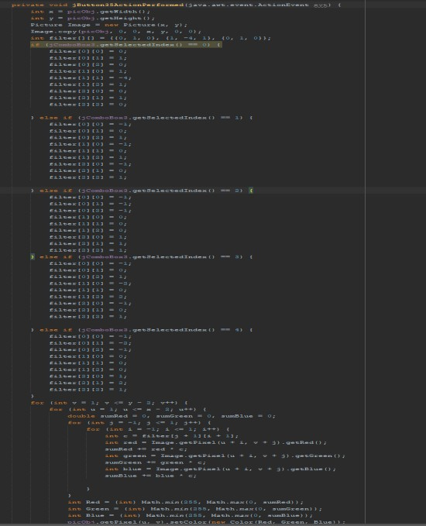Laplacian Filter Code:

Median Filter:

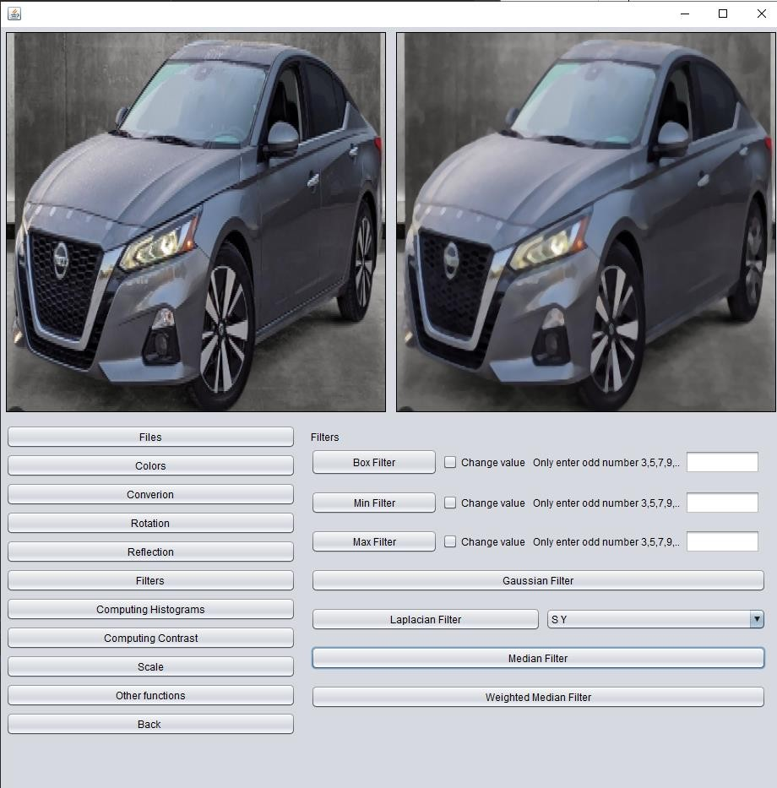



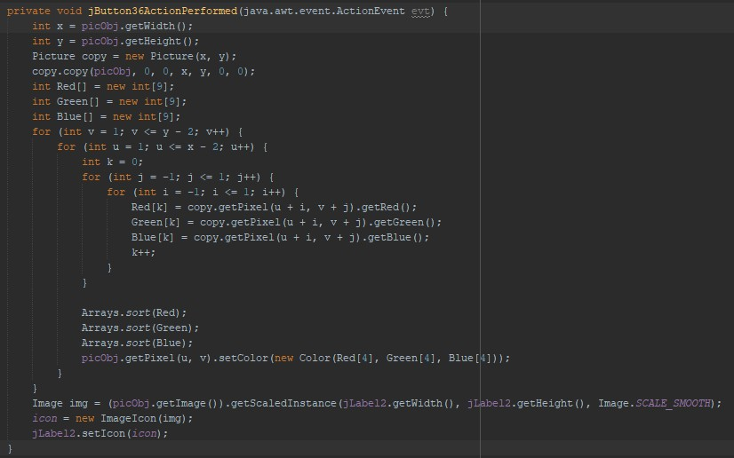Median Filter Code:

Weighted median Filter:

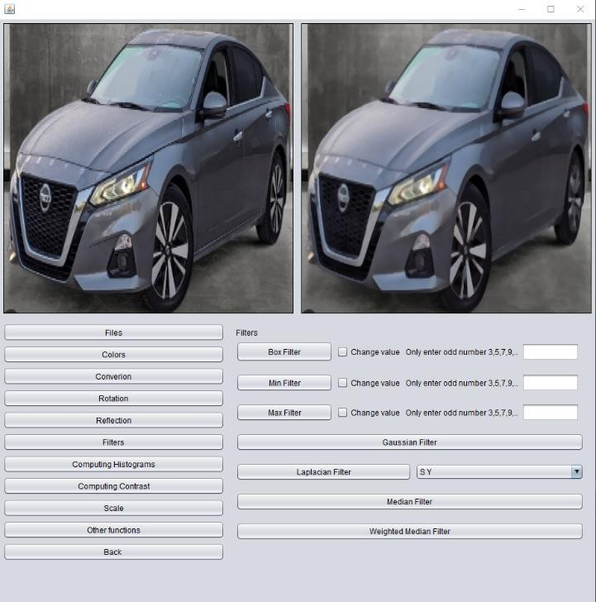



Weighted median Filter Code:

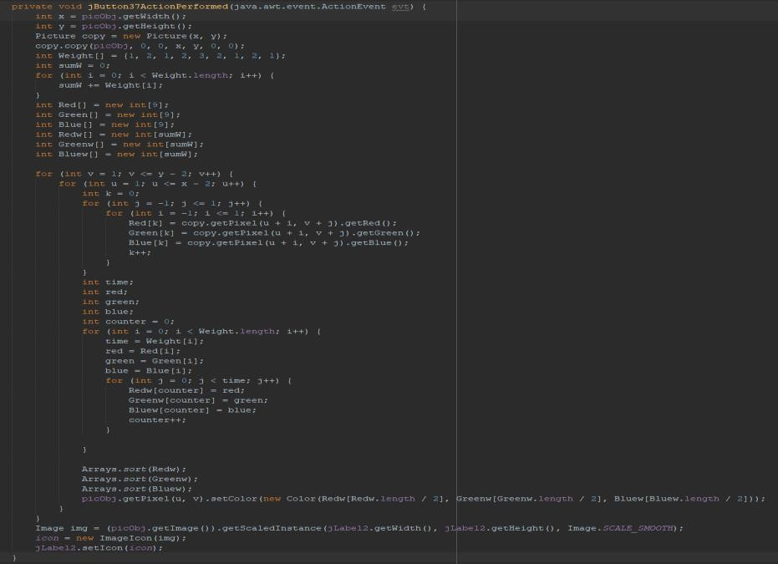

# Red Eye Reduction using thresholding technique:

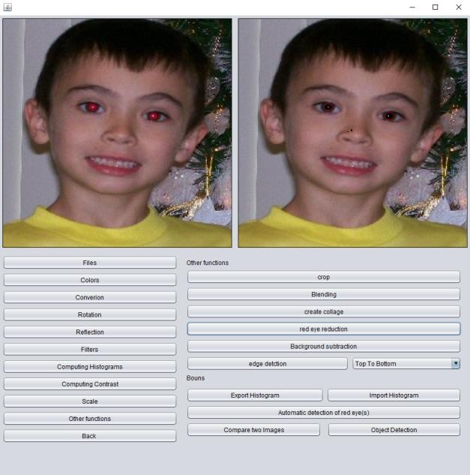



By pressing the "Red Eye Reduction" button, the user can reduce the red eye in the selected picture. The user will then be prompted to select the area of the picture with the red eye and choose a color to replace it. Finally, the user will adjust the thresholding value and the resulting image will be displayed without the red eye.

Red Eye Reduction using thresholding technique Code:

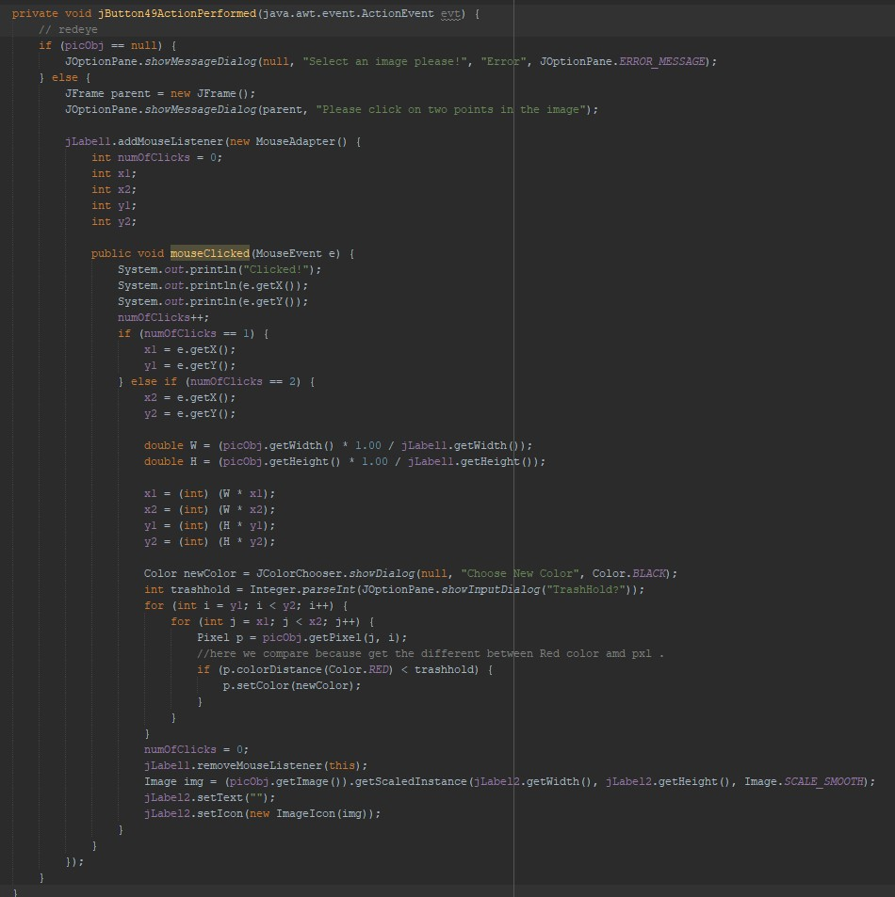



# Automatic detection of red eyes:

To detect red eyes in an image, simply press the "Automatic Detection of Red Eyes" button. This feature utilizes OpenCV, an external library, to identify and outline the red eyes in the image with a rectangle. The result is a picture that clearly highlights the red eyes.



Automatic detection of red eyes Code:

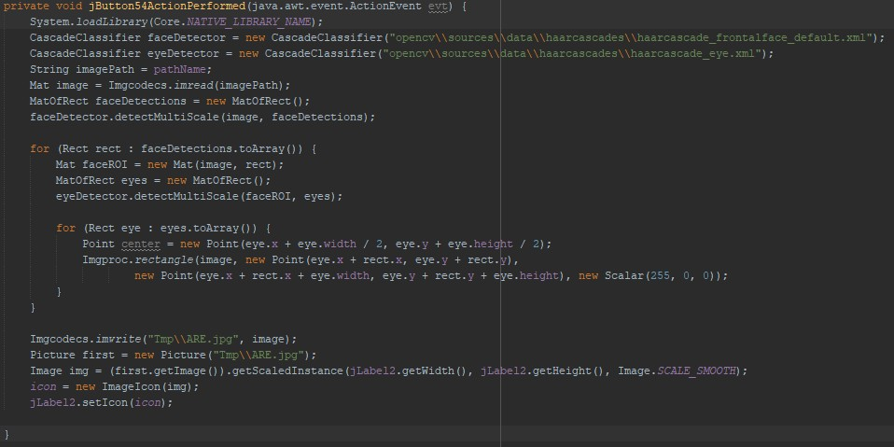

# Background Subtraction:

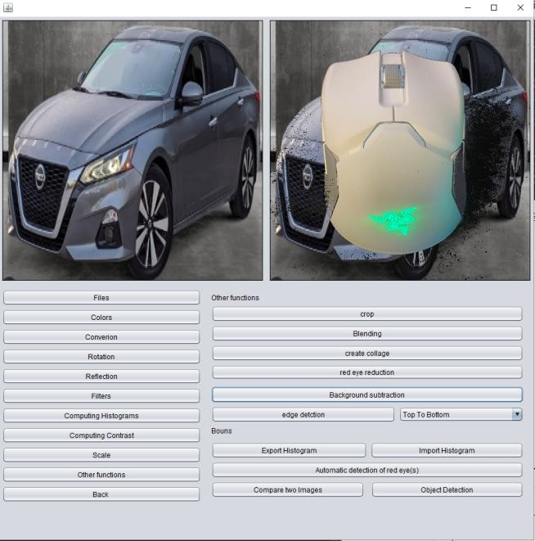



Background Subtraction Code:

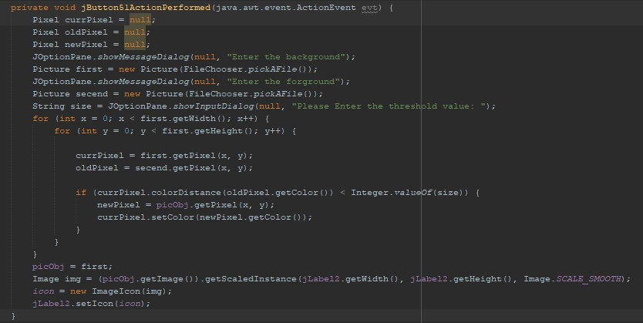



# Edge Detection methods:

Users can select an image and then choose from one of the three options in the combo box to apply edge detection - top-bottom detection, left-right detection, or merge (which combines the two detections in one picture). Once they have made their selection, they must press the "Edge Detection" button to view the result.



Edge Detection methods Code:

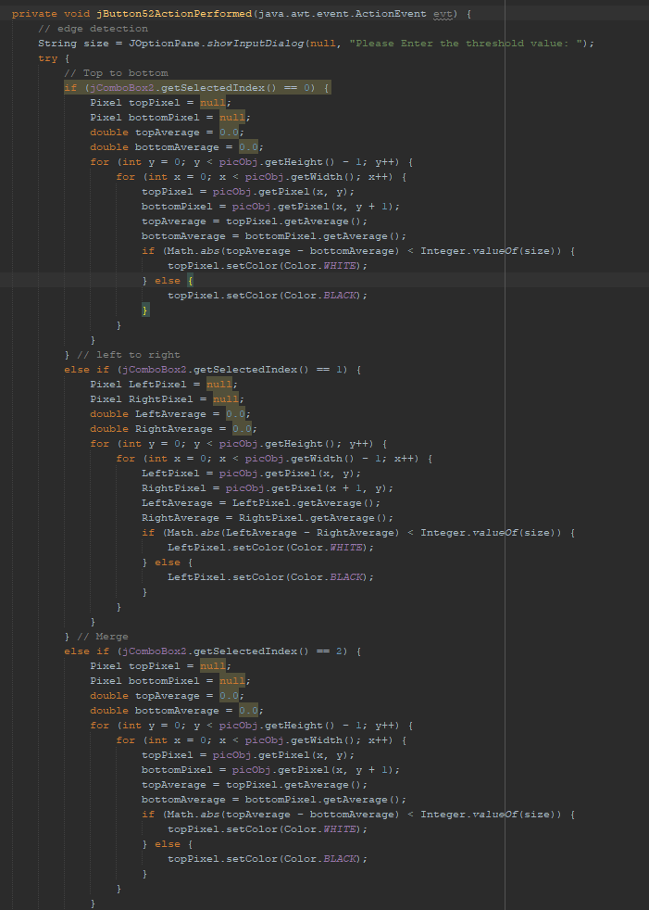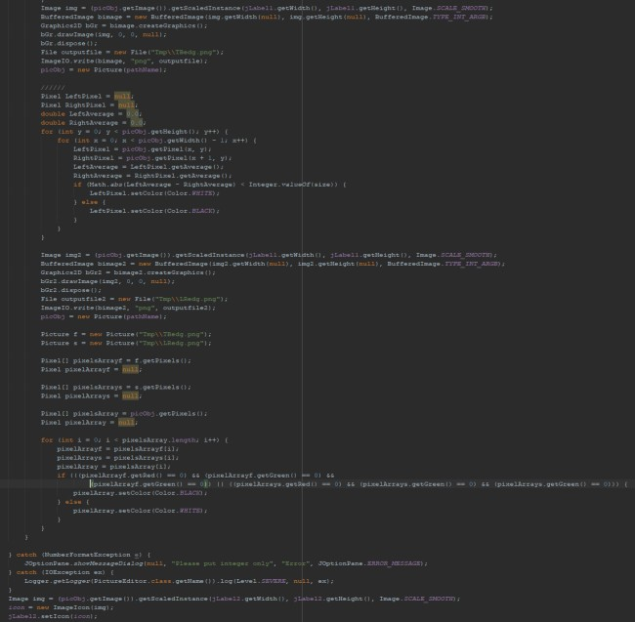

# Change Volume Using Slider:

** For listening the sound go to GitHub

Users can adjust the volume of their chosen sound using a slider. Moving the slider to the right increases the volume, while dragging it left decreases the volume. To hear the adjusted sound, the user must press the "Play" button.

Change Volume using a slider code:

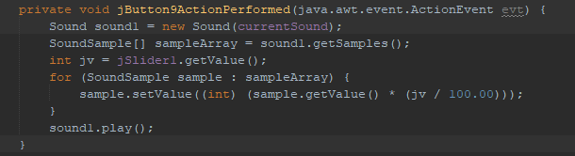



# Graphical user interface, application Description automatically generated29 - Clipping a given sound:

** For listening the sound go to GitHub

Users can clip the sound of their selection by pressing the "Clip" button and then specifying the start and end index. To hear the result, press the "Play" button.

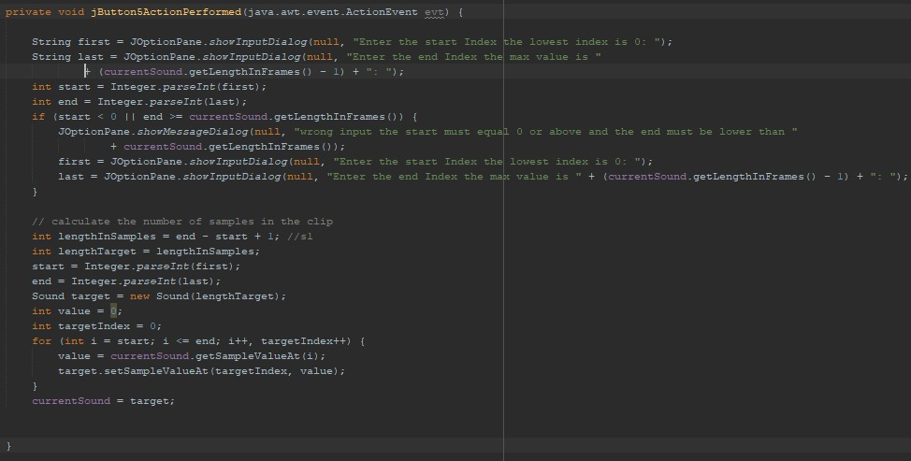Clip code:



# Splicing at least two sounds together keeping the silent zone:

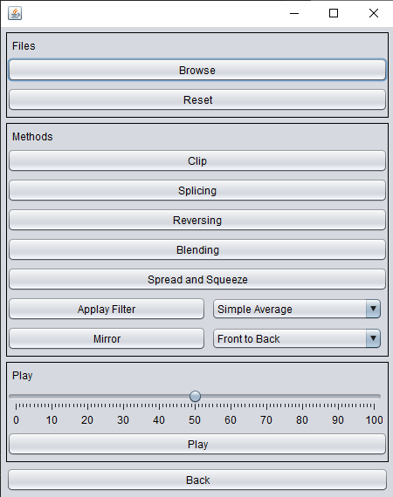

** For listening the sound go to GitHub

To splice two or more sounds together with a silent zone between them, users must first press the "Splicing" button. They will be asked to enter the number of seconds of silence they'd like between the sounds. After inserting the second sound, they will be asked if they'd like to splice another sound. To hear the result, users must press the "Play" button.



Splice code:

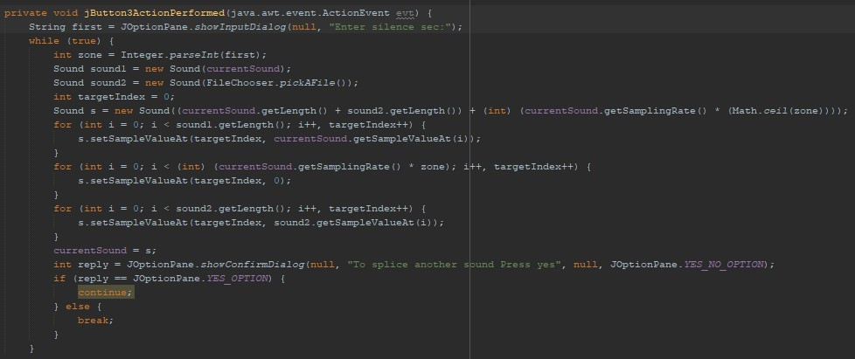



# Graphical user interface, application Description automatically generatedSpread & squeeze a sound:

** For listening the sound go to GitHub

By pressing the "Spread and Squeeze" button, the user can manipulate sound, selecting it first. The sound will be spread into a 4 second duration and then squeezed into 1 second. The outcome can be heard by pressing the "Play" button.



Spread & squeeze code:

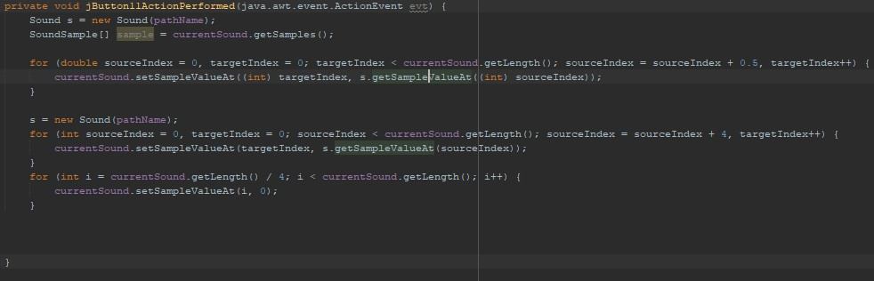

# Reversing and Mirroring:



** For listening the sound go to GitHub

Users can reverse the sound they have selected by pressing the "Reversing" button. They can also mirror the sound by selecting the desired option from the combo box and pressing the "Mirror" button.



Once they have made the desired changes, they can press the "Play" button to hear the altered sound.

Reversing code:

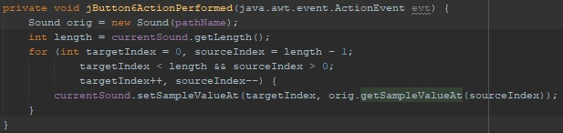

Mirror code:

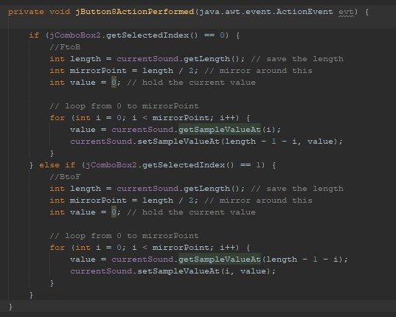



# Graphical user interface, application Description automatically generatedBlending Two or more sounds:

** For listening the sound go to GitHub

Users can blend two or more sounds into one sound by pressing the "Blending" button. Then, they will select the desired sound and blend it to the already selected sound. The program will then ask if they want to add more sounds or not. If yes, they will select another sound. Finally, they must press the "Play" button to hear the blended sound.



Blend code:

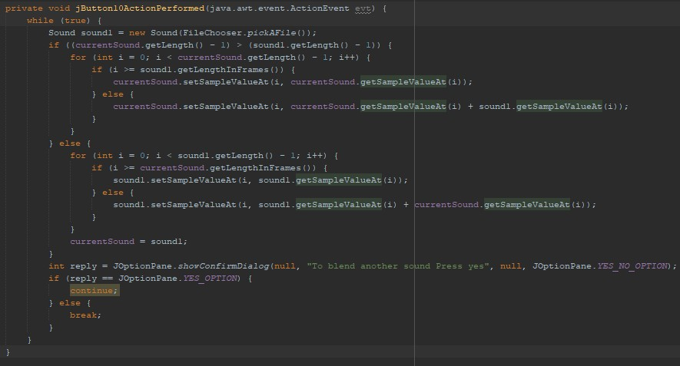



# Graphical user interface, application Description automatically generatedApply simple average, weighted average, max, min and median filters on sounds.

** For listening the sound go to GitHub

Users can modify the selected sound by applying different filters. To apply the filter they want, they must select it from the combo box and press the "Apply filter" button. To hear the changed sound, they must then press the "Play" button.



SoundFilters code:

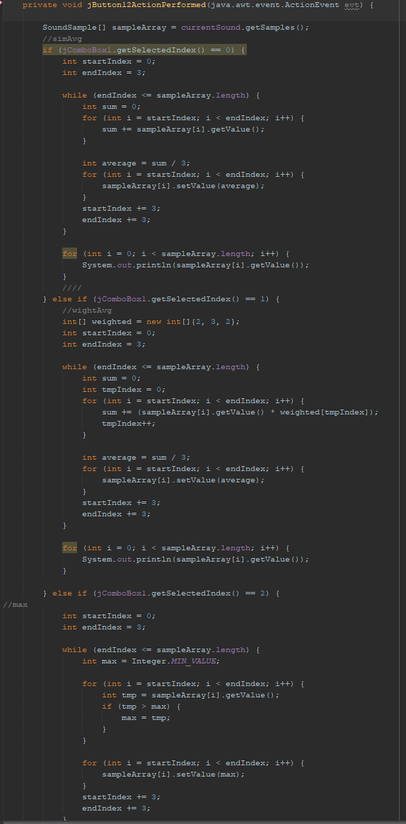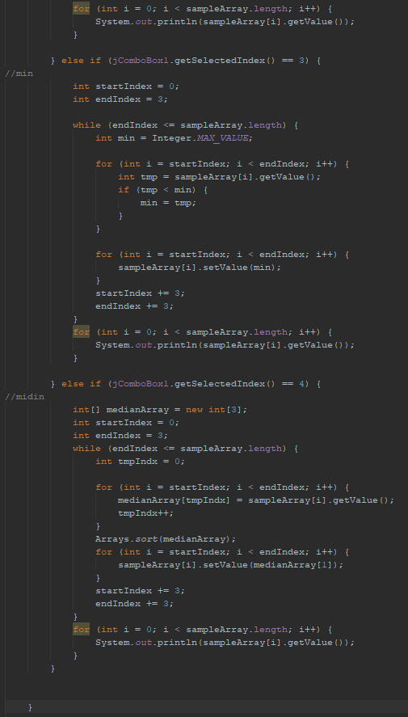



# Create Rectangle Movie method, Show it is moving from top right corner to bottom left, curved trajectory:

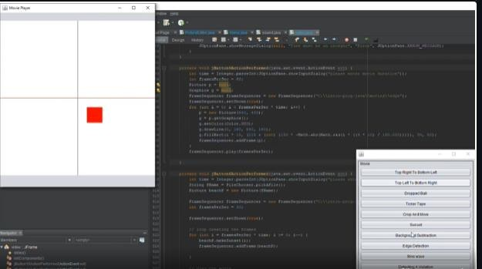

** For watching the video go to GitHub

Press the "Top Right To Bottom Left" button to watch the RecatangleMovie move from the top right corner to the bottom left corner. If you'd like to watch the rectangle move from the top left corner to the bottom right corner, press the "Top Left To Bottom Right" button. After pressing these buttons it will ask the user to enter the movie duration in seconds to show the seconds that he inserted.



Top right to bottom left code:

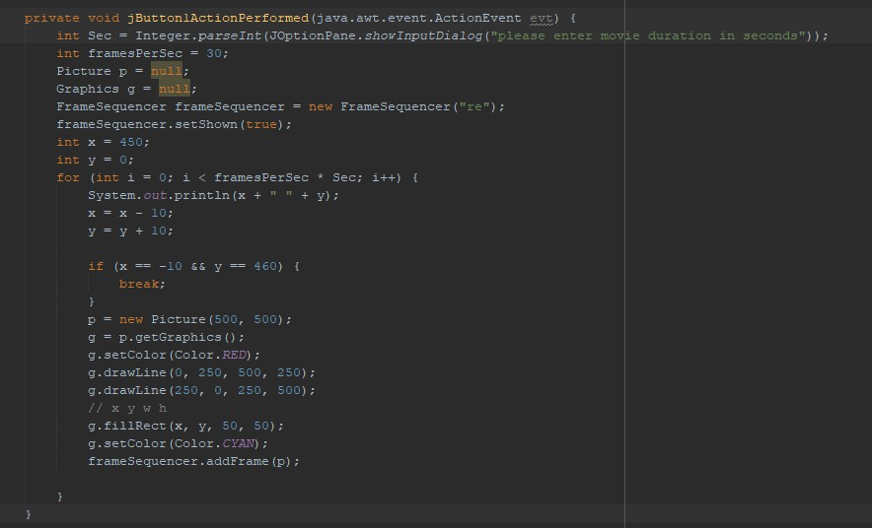



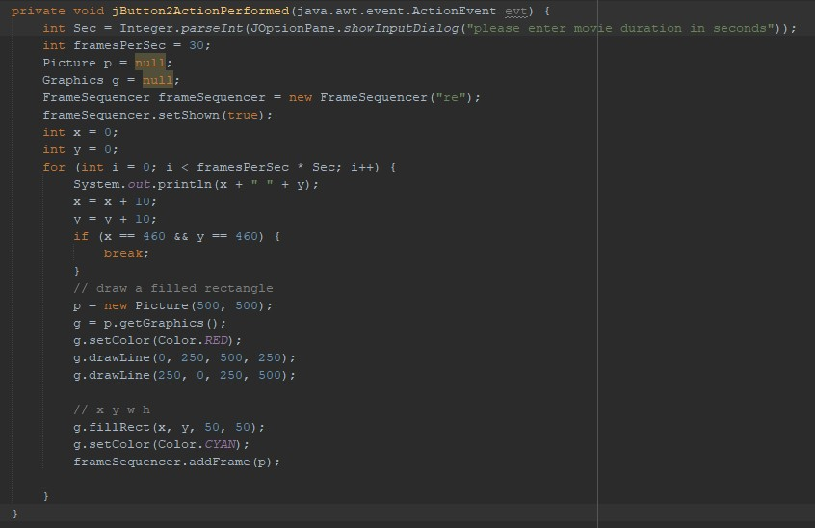Top Left to bottom Right code:

# Create Rectangle Movie method, Show the trajectory of motion followed by a Sine function:

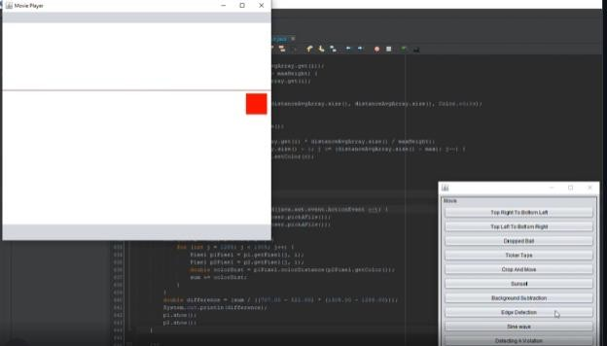



** For watching the video go to GitHub

By pressing the "Sine wave" button, the user can insert the desired number of seconds for the video to continue. This will cause a rectangular shape to move in a sine wave motion.

Sine wave code:

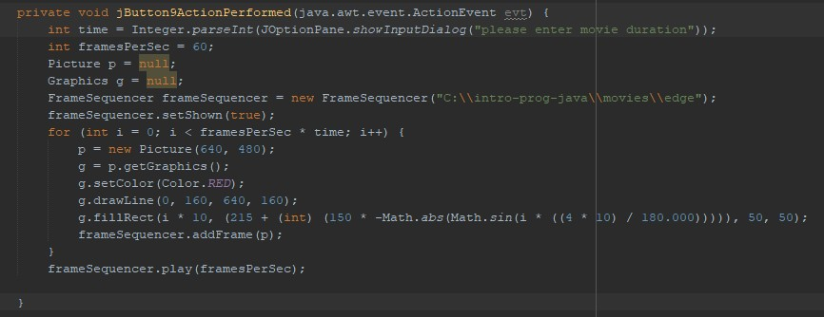

# Create Rectangle Movie method Show the trajectory of motion, when a ball is dropped on the floor:

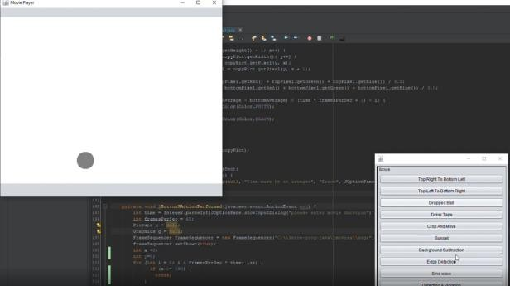



** For watching the video go to GitHub

By pressing the "Dropped Ball" button, the user can insert the desired number of seconds for the video to continue. This will cause a circle to move in a drop motion.

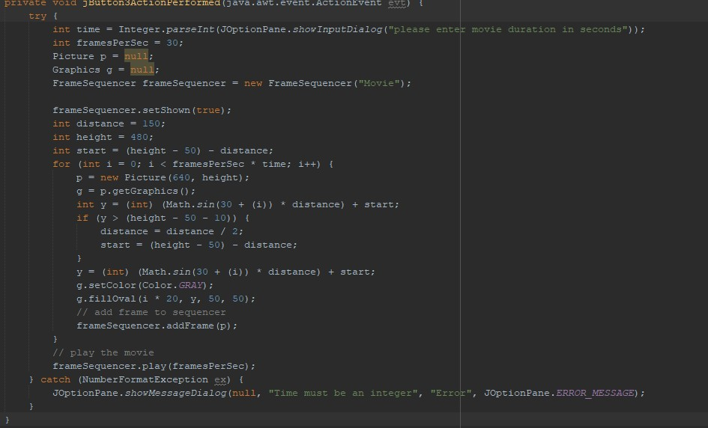Dropp ball code:



# CreateTickerTapeMovie – A string of text moves back and forth and does not disappear from screen.

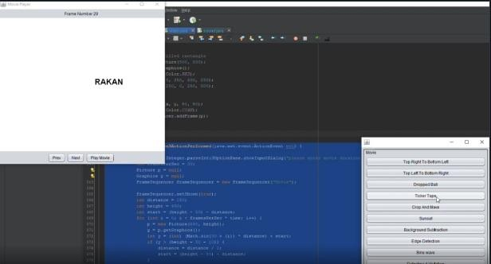

** For watching the video go to GitHub

By pressing the "Tricker Tape" button, the user can enter the number of seconds they wish for the video to run and the text they want to move. This will cause the selected text to move along the screen according to the number of seconds specified



TickerTapeMovie code:

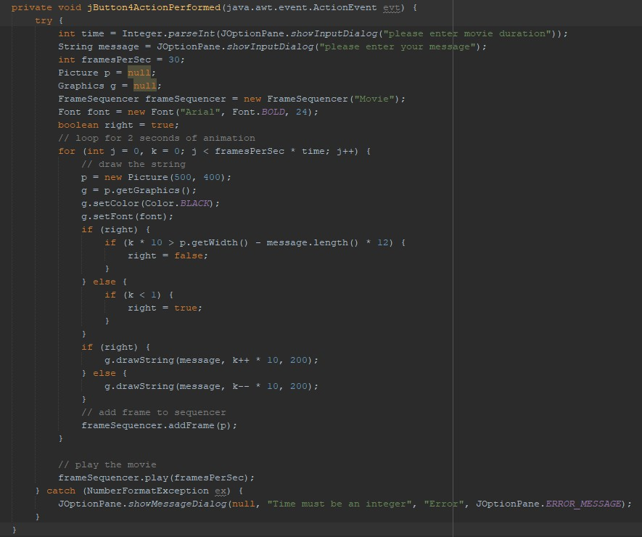



# Create a movie, cropping a part of given image that appears randomly on screen:

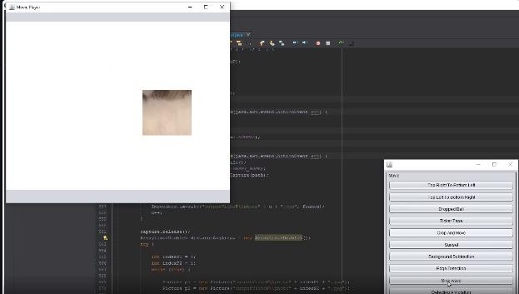

** For watching the video go to GitHub

In this method, the users must specify the duration of the video and the picture that they want to crop. Afterwards, the method will randomly select a portion of the image to be moved.



Cropping and move in a video code:

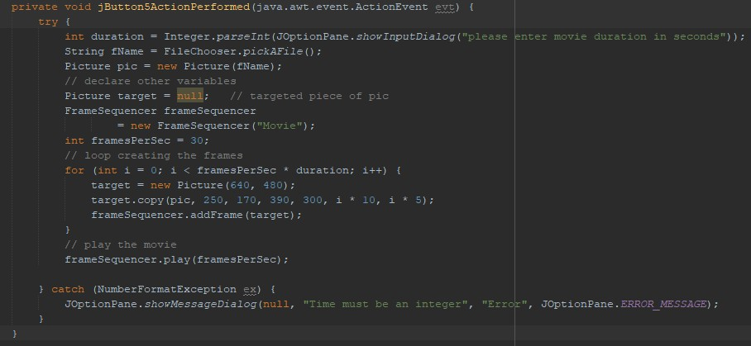

# Create Sunset movie:



** For watching the video go to GitHub

By pressing the "Sunset" button, the user can enter the number of seconds they wish for the video to run and the the image they want to make sunset effect. This will cause sunset effect to the photo by time the user selected according to the number of seconds specified.

Create Sunset movie Code:

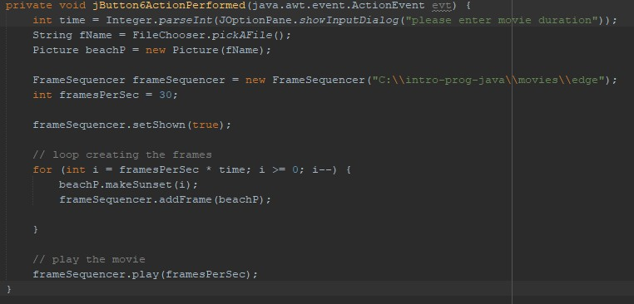



# Back Ground Subtraction Movie:

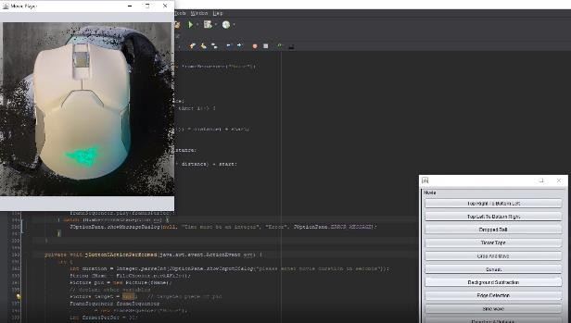

** For watching the video go to GitHub

This method allows the user to create a new video background by entering the duration of the video and three pictures. The first picture will be used as the new background, the second will be used as the foreground, and the third will be cut out and removed from the foreground. After these steps are completed, the first picture will be used as the new background of the video.



Back Ground Subtraction Movie Code:

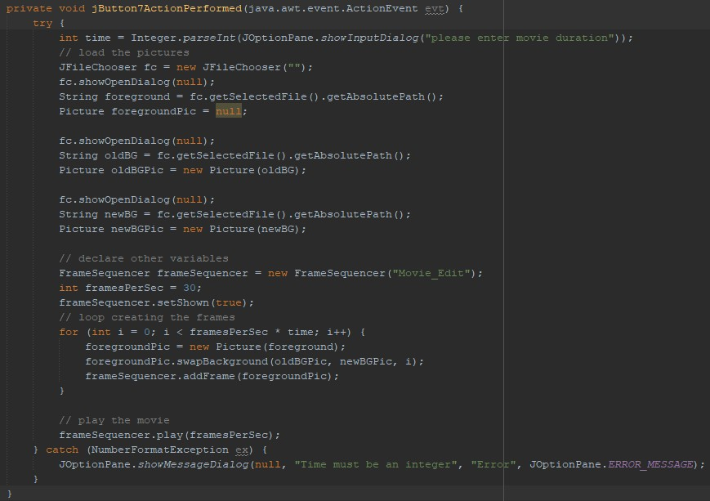

# Edge Detection Movie:

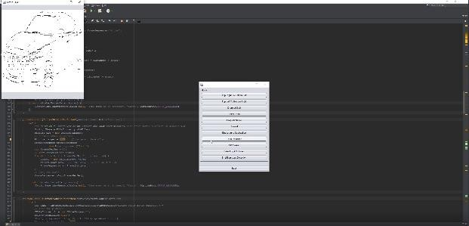



** For watching the video go to GitHub

In this method, the user needs to specify the duration of the video and upload an image to detect the edges. The method will then output a video displaying the detected edges.

Edge Detection Movie Code:

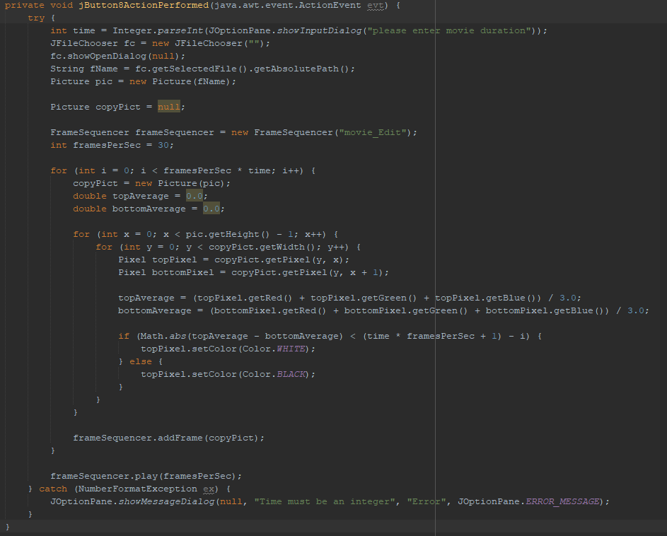



# Compare two Images:

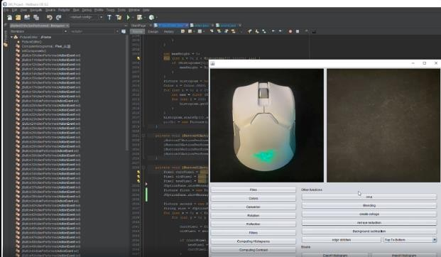

In this method, the user will insert two pictures which will then be compared to determine how much difference there is between them. If the difference is less than 50, it indicates a small difference between the two images. If the difference is greater than 50, it indicates a significant difference.

Compare two Images code:

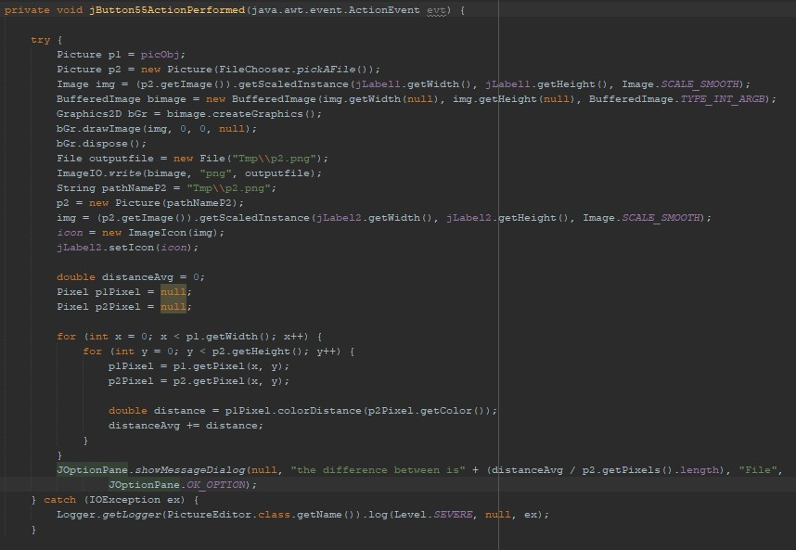



# Shot boundary detection:

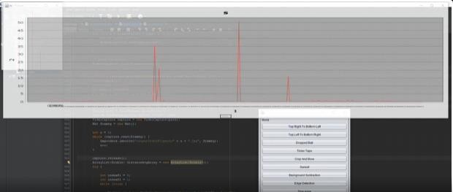

** For watching the video go to GitHub

In this method, the user can input a video and view a chart that shows the differences between the frames of that video. If the video has significant differences between the frames, the chart will show a high value, whereas if there are not many differences, the chart will remain low.



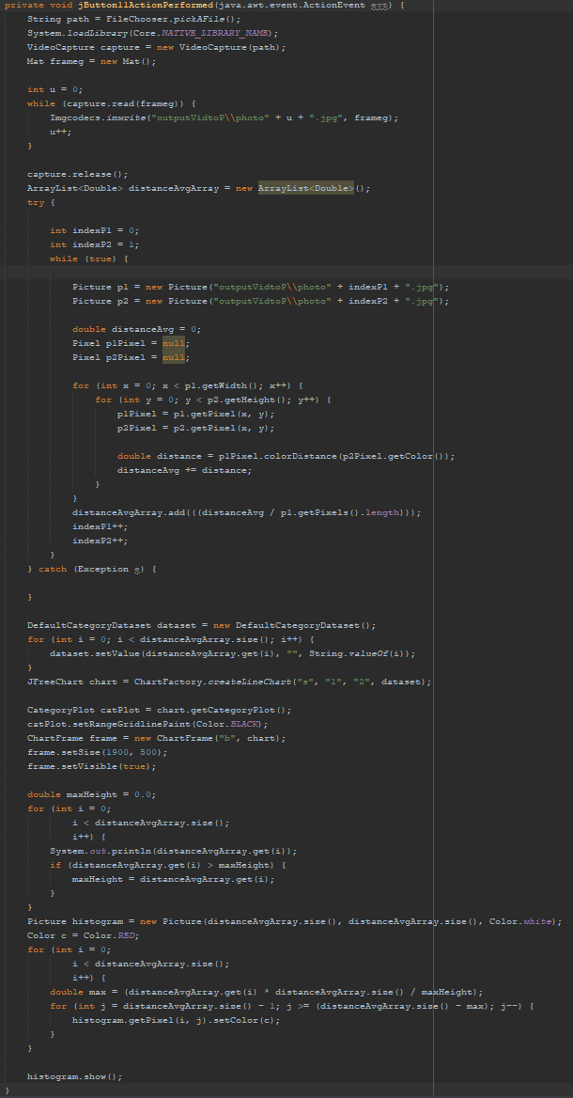Shot boundary detection code:



# A picture containing chart Description automatically generatedDetecting a violation of traffic rule:

** For watching the video go to GitHub

This method allows users to upload two photos to check for any traffic rule violations. If a violation is detected, such as a vehicle passing or touching the yellow line, the user will be notified of the violation. If no violation is found, the user will be informed that there is no violation.

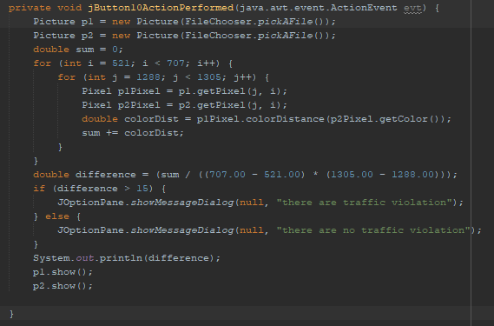Detecting a violation of traffic rule code



# Object Detection:

** For watching the video go to GitHub

This method can be used to detect objects, such as heads, and draw a rectangle around them. To increase accuracy, it needs to be trained further to recognize more objects.

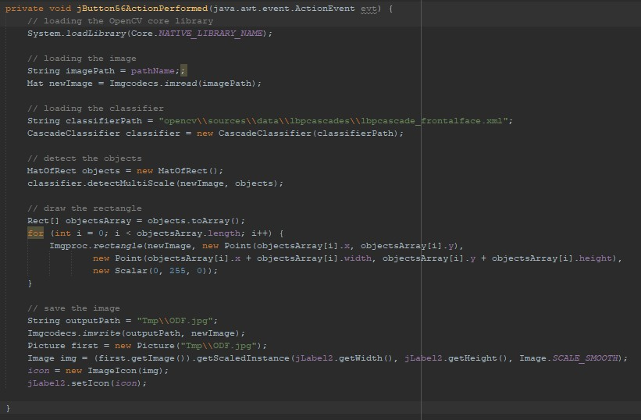Object detection code:

# Problems that we faced while doing the project:

One of the most difficult challenges we faced during this project was dealing with the size of pictures that the user would insert. Many methods did not accept differences in size, resulting in an array out of bounds error. Additionally, uploading and pushing the project onto GitHub was a significant problem because of its file size restrictions. We also encountered difficulties with OpenCV, both in terms of implementation and usage, as it did not support our Netbeans version. Additionally, a large amount of effort was put into making the detailed documentation for this project. Lastly, we faced a lack of codes and information, such as shot boundary, which was necessary for the project’s completion.

# References:

[1] B. Ericson, "Picture class," in IntroCS, Princeton University, https://introcs.cs.princeton.edu/java/stdlib/javadoc/Picture.html, Accessed: Month Day, Year.

[2] B. Ericson, "SimplePicture class," in UIC, University of Illinois at Chicago, https://www2.cs.uic.edu/~i101/doc/SimplePicture.html, Accessed: Month Day, Year.

[3] "RGB to HSV color conversion," RapidTables, https://www.rapidtables.com/convert/color/rgb-to-hsv.html, Accessed: Month Day, Year.

[4] OpenCV Development Team, "OpenCV library," in OpenCV, Accessed: Month Day, Year.

[5] B. Ericson, "Sound class," in Duke University, https://www2.cs.duke.edu/courses/spring07/cps001/doc/mediaClasses/Sound.html, Accessed: Month Day, Year.

[6] B. Ericson, "MovieMaker class," in Georgia Institute of Technology, Accessed: Month Day, Year.

[7] B. Ericson, "FrameSequencer class," in UIC, University of Illinois at Chicago, https://www2.cs.uic.edu/~i101/doc/FrameSequencer.html, Accessed: Month Day, Year.